 PROJECT REPORT

Factors Influencing Traffic Accident Severity

Mentor : Huỳnh Nam

**March 20, 2025**

Nhóm sinh viên thực hiện:

Tạ Quang Tuấn SE190841

Phạm Hoàng Nam SE192423

Nguyễn Cao Thành Trung SE191057

**FEEDBACK**

**…………………………………………………………………………………………...**

**…………………………………………………………………………………………...**

**…………………………………………………………………………………………...**

**…………………………………………………………………………………………...**

**…………………………………………………………………………………………...**

**…………………………………………………………………………………………...**

**…………………………………………………………………………………………...**

**…………………………………………………………………………………………...**

**…………………………………………………………………………………………...**

**…………………………………………………………………………………………...**

**…………………………………………………………………………………………...**

**…………………………………………………………………………………………...**

**…………………………………………………………………………………………...**

**…………………………………………………………………………………………...**

**…………………………………………………………………………………………...**

**…………………………………………………………………………………………...**

**…………………………………………………………………………………………...**

**…………………………………………………………………………………………...**

**…………………………………………………………………………………………...**

**…………………………………………………………………………………………...**

**…………………………………………………………………………………………...**

**…………………………………………………………………………………………...**

**…………………………………………………………………………………………...**

**…………………………………………………………………………………………...**

**…………………………………………………………………………………………...**

**…………………………………………………………………………………………...**

**…………………………………………………………………………………………...**

**…………………………………………………………………………………………...**

**…………………………………………………………………………………………...**

**…………………………………………………………………………………………...**

**…………………………………………………………………………………………...**

**…………………………………………………………………………………………...**



lOMoARcPSD|46342985

Contents

1. Introduction 0

**1.1 Project Objective** 0

**2. Problem definition** 1

**2.1 Problem Description** 1

**2.2 Approach** 1

**2.3 Scope** 2

**3. Data collection** 2

**4. Data understanding** 3

4.1 Load Data 3

4.2 Dataset Information 4

4.3 Data types of each variables 5

***4.4 Link dataset*** 5

**5. Data processing** 6

**5.1** Proposed Data Model: 11

**5.2 Modeling** 12

**6. EDA** 17

**6.1** **Analysis of Quantitative Variables** 17

**6.2** **Analysis of Qualitative Variables** 19

**6.3 Visualization** 26

**- Correlation** 26

**- Matrix covariance** 27

- **Scatter_matrix** 27

**7.Inferential Analysis** 28

**8.Feature Selection** 33

**8.1** **Impact of Features on the Target Variable** 33

**8.2** **Find Insight** 34

**9.Business Intelligence** 47

**9.1** **Dashboard Power Bi** 47

**10.** **Conclusion** 48



**REPORT ON FACTORS AFFECTING THE SEVERITY OF ROAD ACCIDENTS**

1. Introduction

Traffic accidents are a serious global issue, causing numerous fatalities and injuries each year. Various factors, including road conditions, weather, lighting, and vehicle types, significantly influence the severity of these accidents. Understanding the key factors contributing to severe accidents can help policymakers, traffic authorities, and urban planners implement effective measures to reduce road casualties.

* This project aims to analyze the factors affecting the severity of traffic accidents using data from real-world incidents. By applying exploratory data analysis (EDA) and machine learning techniques, we seek to identify patterns and correlations between accident severity and various environmental, infrastructural, and situational factors. The findings from this analysis can be used to propose targeted interventions, such as improving road infrastructure, optimizing traffic regulations, and enhancing public awareness of traffic safety.
* By leveraging data-driven insights, this study contributes to the broader effort of minimizing traffic-related fatalities and injuries, ultimately leading to safer roads and improved transportation systems.This study analyzes a dataset of **road accident casualties in the UK (2019-2022)**, containing **660,679 records and 14 attributes**. The objective is to identify key factors such as **weather conditions, lighting, road type, and vehicle type** that contribute to the severity of accidents.
* Using **Python** for statistical analysis and visualization, this report explores data trends, applies feature selection, and provides recommendations to enhance road safety.

## **1.1 Project Objective**

* **- The primary objective of this study is to analyze the key factors influencing the severity of road accidents. By examining various attributes such as weather conditions, lighting, road type, and vehicle type, the study aims to identify patterns and correlations that contribute to accident severity. The findings will help develop recommendations for improving traffic safety and reducing the number of severe accidents.**

# **2. Problem definition**

**2.1 Problem Description**

* **Input:**  
  A dataset containing traffic accident records with key variables, including accident severity, road conditions, weather conditions, lighting conditions, vehicle types, and geographic location (latitude and longitude).
* **Output:**
  + **Descriptive Statistics:** Summary statistics for key variables, including mean, median, and standard deviation.
  + **Data Analysis:** Insights extracted from historical traffic accident data.
  + **Data Visualization:** Accident distribution maps, heat maps, and correlation graphs.
  + **Feature Analysis:** Identification of key factors influencing accident severity.
  + **Machine Learning Models:** Predictive models to analyze accident severity based on environmental and road-related factors.
  + **Analytical Report:** Summary of findings, accident trends, and major contributing factors.

**2.2 Approach**

1. **Data Collection:**
   * Gather traffic accident records, including accident severity, road conditions, weather conditions, lighting conditions, vehicle types, and geographic location.
2. **Data Preprocessing:**
   * **Tools:** Python, MySQL.
   * Handle missing values, remove duplicates, detect and manage outliers, and format data for consistency.
3. **SQL Analysis:**
   * **Tools:** MySQL.
   * Use SQL queries to filter, aggregate, and extract meaningful insights from accident data.
4. **Python Analysis & Statistical Analysis:**
   * **Tools:** Python.
   * Perform exploratory data analysis (EDA) and compute statistical measures (mean, median, standard deviation).
5. **Data Visualization:**
   * **Tools:** Python.
   * Create accident distribution maps, heat maps, and correlation graphs to identify trends.
6. **Feature Analysis & Machine Learning:**
   * **Tools:** Python, Scikit-learn.
   * Identify the most influential factors affecting accident severity and build predictive models.
7. **Analytical Reporting:**
   * **Tools:** Power BI.
   * Develop dashboards and reports summarizing key findings, accident trends, and influencing factors.

**2.3 Scope**

* **Dataset:** Historical traffic accident records from 2019 to 2024.
* **Timeframe:** From January 1, 2019, to December 31, 2024.
* **Variables:**
  + **Dependent variable:** Accident Severity (Slight, Serious, Fatal).
  + **Independent variables:** Factors that may influence accident severity, including:
    - Weather Conditions (e.g., sunny, rainy, foggy, stormy).
    - Road Conditions (e.g., dry, wet, icy, flooded).
    - Lighting Conditions (e.g., daylight, streetlights on, streetlights off, no lighting).
    - Road Type (e.g., single carriageway, dual carriageway, roundabout).
    - Vehicle Type (e.g., cars, motorcycles, buses, trucks).
* **Objectives:**
  + Analyze the relationship between accident severity and environmental/road factors.
  + Identify the impact of each factor on accident severity.
  + Apply machine learning models to predict accident severity based on input variables.
  + Visualize data to detect trends and correlations among factors.
* **Exclusions:**
  + Forecasting future accident occurrences.
  + Analysis of traffic accidents outside the given timeframe (2019-2024).

# **3. Data collection**

**3.1 Data Source**

The dataset was collected from **Kaggle**, specifically from the project **Accident Casualties Prediction** by **Kerem Ozakca**.

* **Source**: Kaggle
* **Collection Period**: The dataset includes traffic accident records from **2019 to 2022**.
* **Dataset Size**: The dataset consists of **660,679 records** with **14 attributes** related to traffic accidents.

**3.2 Data Collection Method**

The data was compiled from traffic accident reports in the **United Kingdom** during the period **2019-2022**. The main attributes in the dataset include:

* **Index**: A unique identifier for each accident.
* **Accident_Severity**: The severity level of the accident (**Severe** or **Slight**).
* **Accident Date**: The date the accident occurred (**DD-MM-YYYY** format).
* **Latitude & Longitude**: The geographical coordinates of the accident location.
* **Light_Conditions**: Lighting conditions at the time of the accident (**daylight, streetlights, no streetlights, etc.**).
* **District Area**: The administrative region where the accident took place.
* **Number_of_Casualties**: The number of people injured or killed in the accident.
* **Number_of_Vehicles**: The number of vehicles involved in the accident.
* **Road_Surface_Conditions**: The surface condition of the road at the time of the accident (**dry, wet, snowy, etc.**).
* **Road_Type**: The type of road where the accident occurred (**one-way, motorway, etc.**).
* **Urban_or_Rural_Area**: Classification of the area (**Urban, Rural**).
* **Weather_Conditions**: The weather conditions at the time of the accident (**clear, rain, strong winds, fog, etc.**).
* **Vehicle_Type**: The type of vehicle involved in the accident (**car, motorcycle, bus, taxi, etc.**).

# **4. Data understanding**

4.1 Load Data

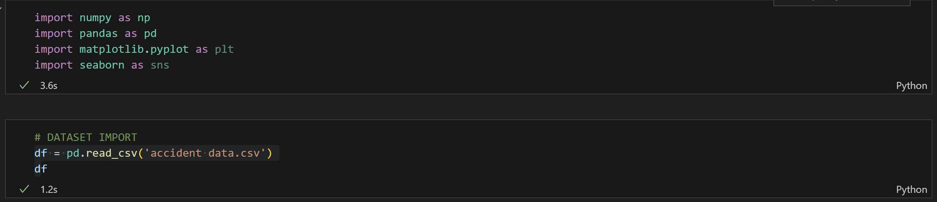

Output:

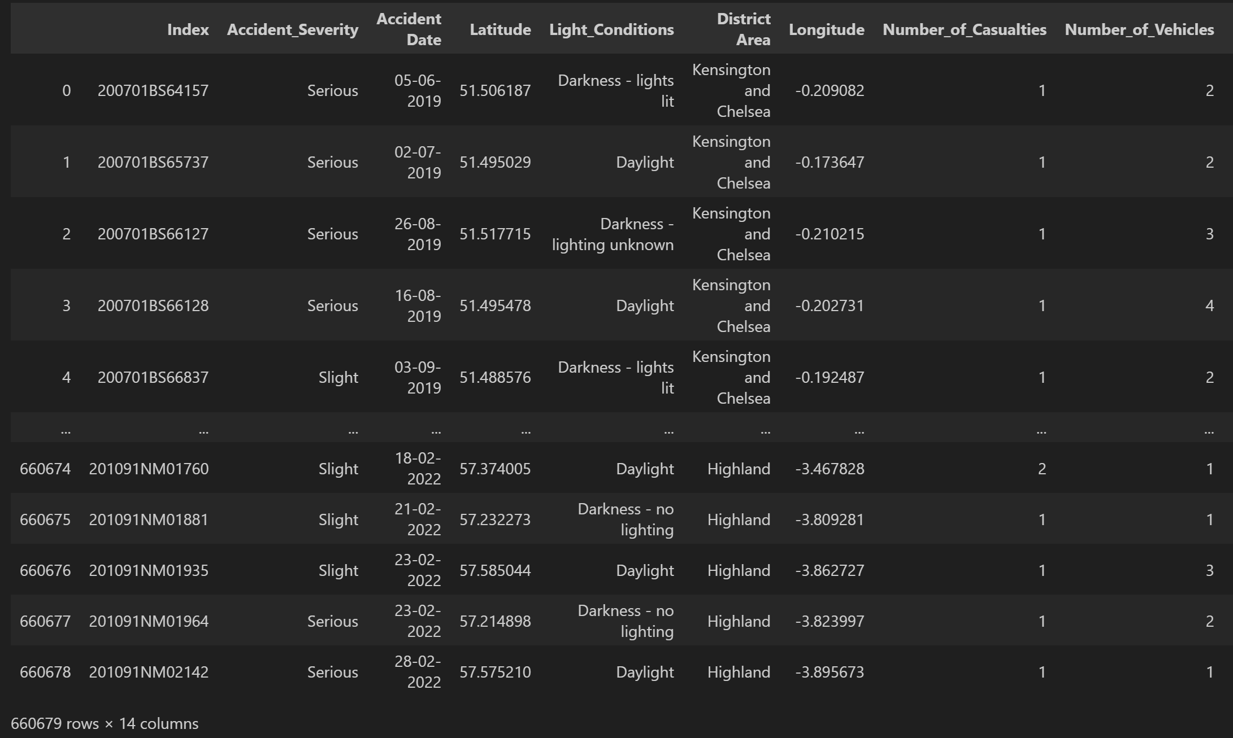

-> Extracted information:

* Number of samples: 660679
* Number of variables: 14

## **4.2 Dataset Information**

* **Dataset Name**: Road Accident Casualties Dataset (Analysis of road accident severity in the UK from 2019 to 2022)
* **Last Updated**: 1 year ago
* **Data Overview**:
* The dataset consists of **660,679 rows** and **14 attributes**, including:

1. **Index** – Unique identifier for the accident.
2. **Accident_Severity** – Severity of the accident (Serious, Slight).
3. **Accident Date** – Date of occurrence (DD-MM-YYYY).
4. **Latitude** – Location coordinates.
5. **Longitude** – Location coordinates.
6. **Light_Conditions** – Lighting conditions at the time of the accident.
7. **District Area** – Administrative region.
8. **Number_of_Casualties** – Number of people injured or killed.
9. **Number_of_Vehicles** – Number of vehicles involved.
10. **Road_Surface_Conditions** – Surface conditions (dry, wet, snow, etc.).
11. **Road_Type** – Type of road (one-way, highway, etc.).
12. **Urban_or_Rural_Area** – Urban or rural classification.
13. **Weather_Conditions** – Weather at the time of the accident.
14. **Vehicle_Type** – Type of vehicles involved.

* **Data Collection Period:** 2019 – 2022
* **Link to Dataset:** Road Accident Casualties Dataset

## 4.3 Data types of each variables

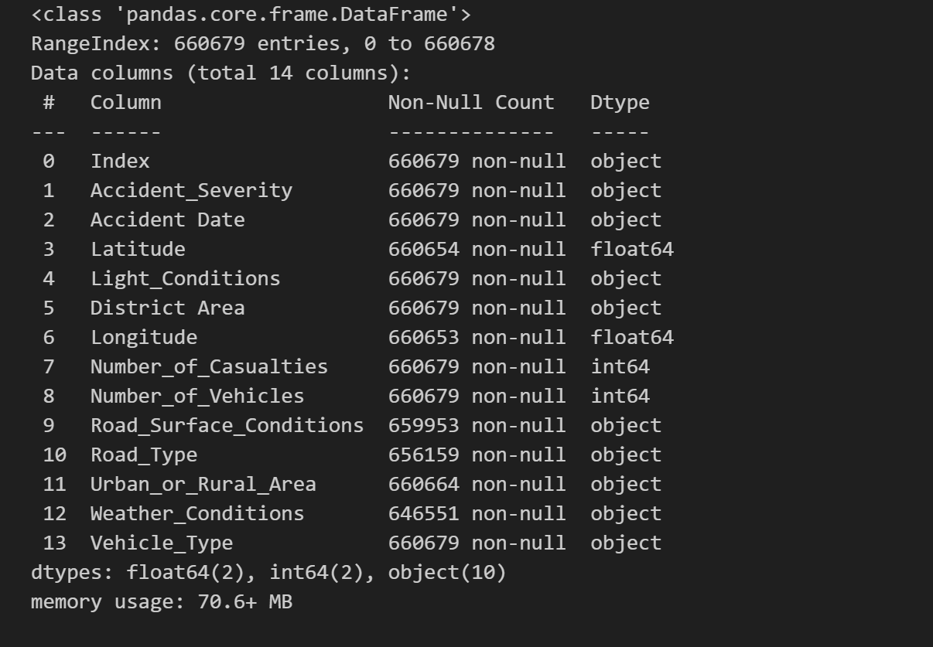

## ***4.4 Link dataset***

Link dataset: [Road Accident Casualties Dataset](https://www.kaggle.com/datasets/nezukokamaado/road-accident-casualties-dataset/data)

# **5. Data processing**

**5.1 Data cleaning**

* **Total records: 660,670 rows**
* **Handling Missing Values:**

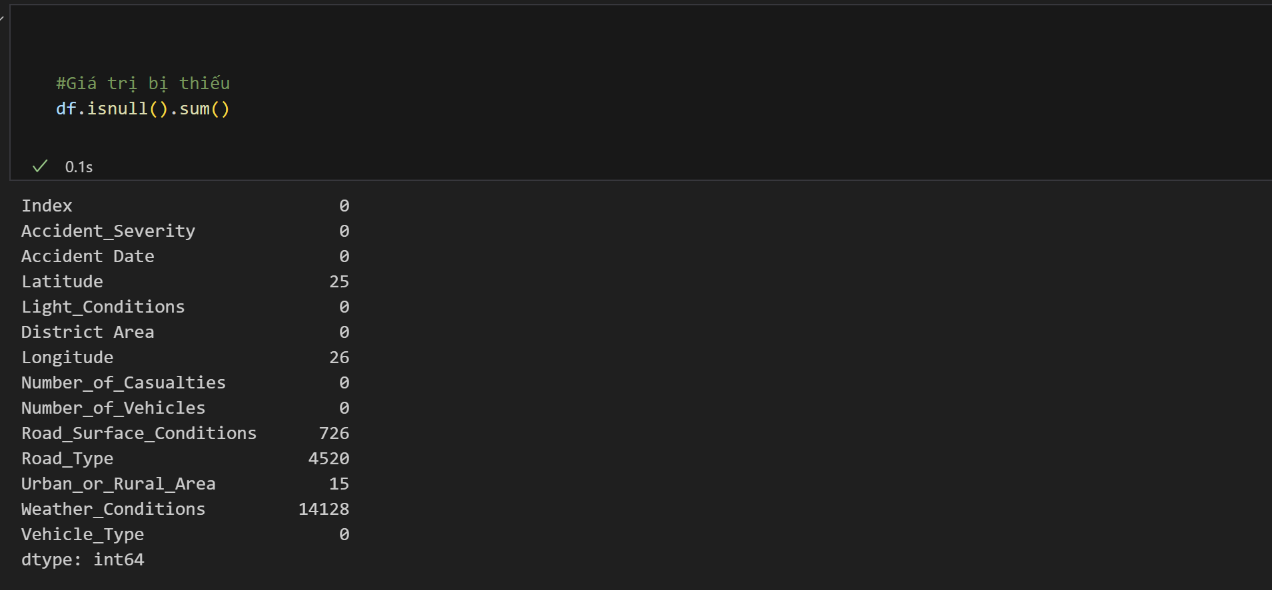

* Heat map :

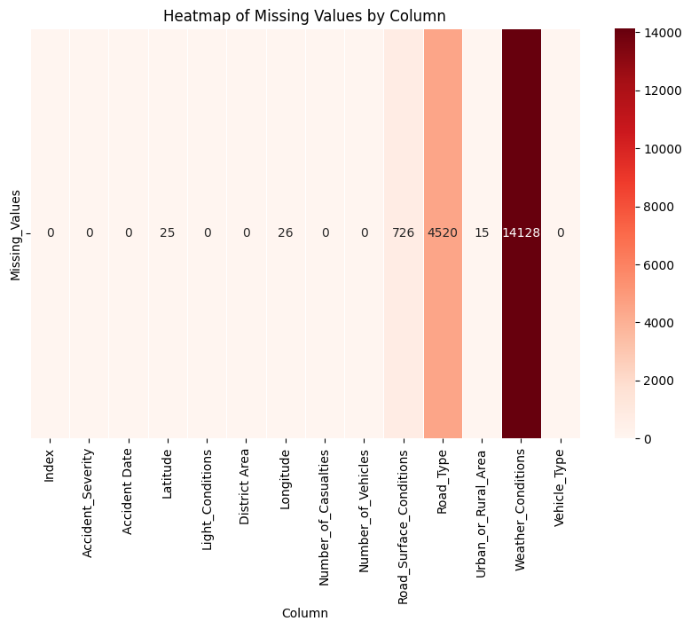

* 1. **Summary min , max of quantities**

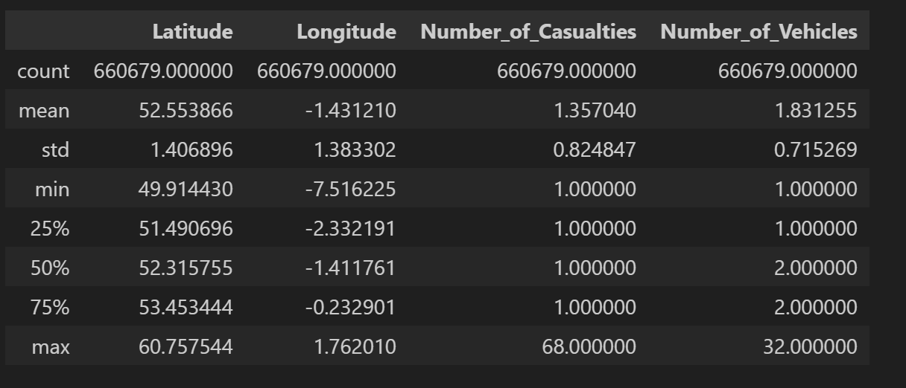

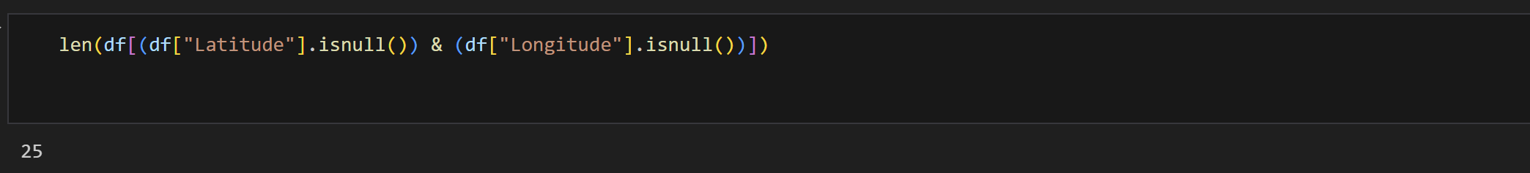

**Heatmap visualization** shows missing data primarily in **Latitude and Longitude**, indicating a dependency between these variables. When the accident location is not recorded, both variables are missing.

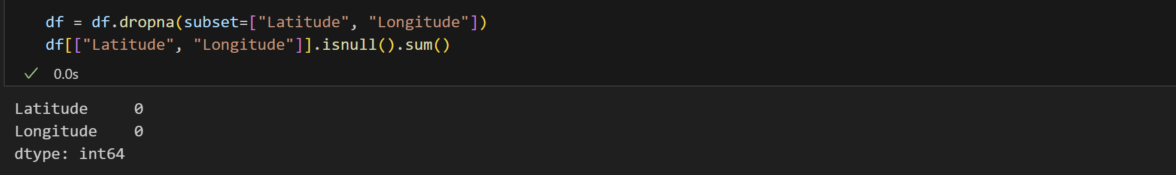

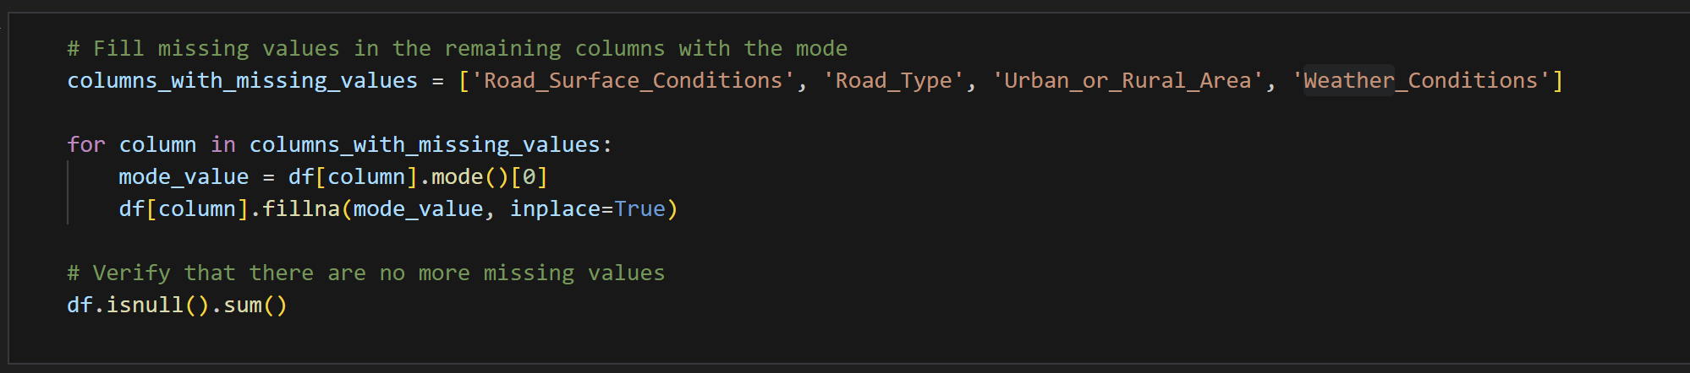

* **Handling missing categorical data**:
  + Variables such as **Road_Surface_Conditions, Road_Type, Urban_or_Rural_Area, and Weather_Conditions** are categorical.
  + The missing values are filled using **mode** (most frequent value) to maintain data consistency.

**After filling :**

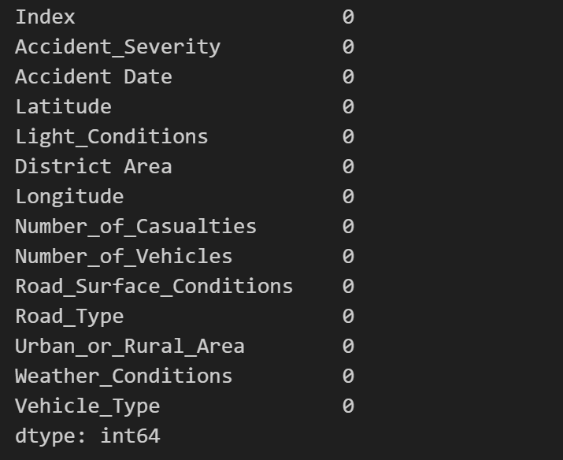

* **Handling Duplicates:**

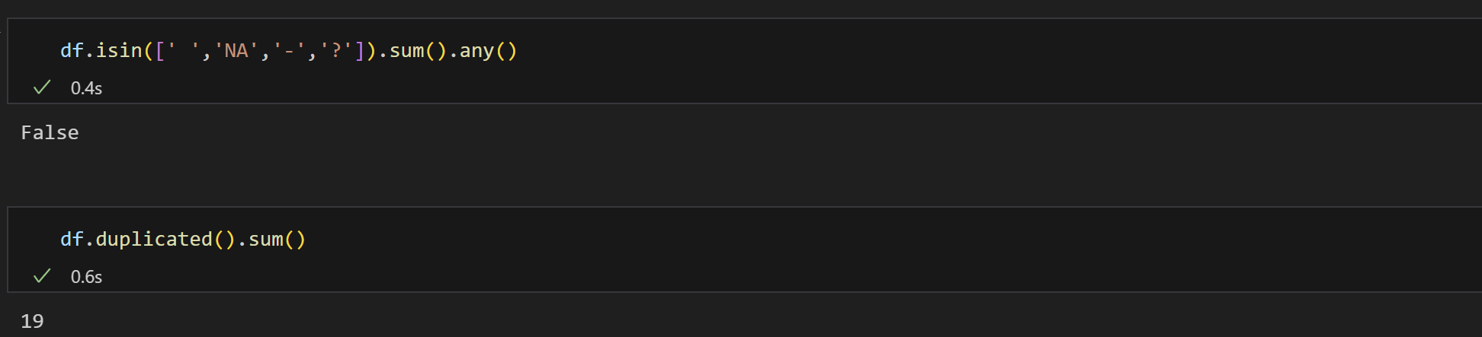

* **Duplicated records** are dropped to prevent skewed analysis.
* A **heatmap after cleaning** confirms that the data is now clean and ready for analysis.

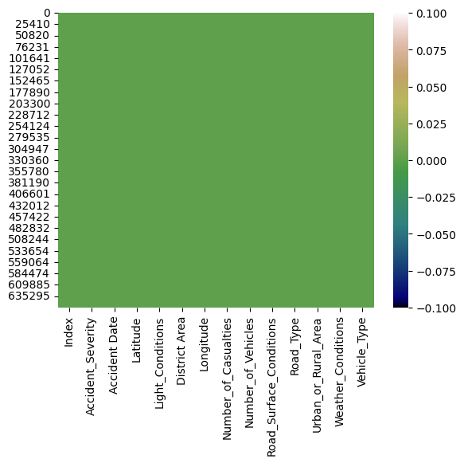

* The dataset is clean.
* **Final dataset**: **660,634 rows and 14 columns** are used for further insight extraction.

**2.3 Purpose of** Proposed Data Model**:**

* Reduce the number of categories for simplicity while preserving important meanings.
* Ensure consistency in values with similar meanings recorded differently.
* Enhance data analysis efficiency and visualization for better trend identification.
* Prevent overfitting in Machine Learning models by grouping similar categories.

### **5.1** Proposed Data Model:

**Light Conditions**

| **Original Value** | **Normalized Value** |
| --- | --- |
| **Darkness - lights lit** | **Dark (lit)** |
| **Daylight** | **Day** |
| **Darkness - lighting unknown** | **Dark (unknown)** |
| **Darkness - lights unlit** | **Dark (unlit)** |
| **Darkness - no lighting** | **Dark (none)** |

##### **Road Surface Conditions**

| **Original Value** | **Normalized Value** |
| --- | --- |
| Dry | Dry |
| Wet or damp | Wet |
| Snow | Snow |
| Frost or ice | Icy |
| Flood over 3cm. deep | Flood |

**Road Type**

| **Original Value** | **Normalized Value** |
| --- | --- |
| **Single carriageway** | **Single Rd** |
| **Dual carriageway** | **Dual Rd** |
| **One way street** | **One Way** |
| **Roundabout** | **Roundabout** |
| **Slip road** | **Slip Rd** |

**Weather_Conditions**

| **Original Value** | | **Normalized Value** | | --- | |
| --- | --- | --- |
| **Fine no high winds** | **Fine** |
| **Raining no high winds** | **Rain** |
| **Fine + high winds** | **Windy** |
| **Raining + high winds** | **Stormy** |
| **Snowing no high winds** | **Snow** |
| **Fog or mist** | **Fog** |
| **Snowing + high winds** | **Blizzard** |

**Vehicle Type**

| **Original Value** | **Normalized Value** |
| --- | --- |
| **Car** | **Car** |
| **Taxi/Private hire car** | **Taxi** |
| **Bus or coach (17 or more pass seats)** | **Bus** |
| **Van / Goods 3.5 tonnes mgw or under** | **Van** |
| **Motorcycle over 125cc and up to 500cc**  **Motorcycle 125cc and under**  **Motorcycle over 500cc**  **Motorcycle 50cc and under** | **Motorcycle** |
| **Goods 7.5 tonnes mgw and over** | **Heavy Goods** |
| **Pedal cycle** | **Bicycle** |
| **Agricultural vehicle** | **Farm Vehicle** |
| **Ridden horse** | **Horse** |
| **Data missing or out of range** | **Unknown** |

## **5.2** **Modeling**

1. Modeling data

Tool: SQL Sever

Code:

CREATE TABLE Weather (

WeatherID INT PRIMARY KEY IDENTITY(1,1),

Weather_Conditions VARCHAR(100) NOT NULL

);

CREATE TABLE Vehicle (

VehicleID INT PRIMARY KEY IDENTITY(1,1),

Vehicle_Type VARCHAR(100) NOT NULL

);

CREATE TABLE Road (

RoadID INT PRIMARY KEY IDENTITY(1,1),

Road_Type VARCHAR(100) NOT NULL,

Road_Surface_Conditions VARCHAR(100),

Light_Conditions VARCHAR(100)

);

CREATE TABLE Accident (

AccidentID INT PRIMARY KEY IDENTITY(1,1),

Accident_Severity INT CHECK (Accident_Severity BETWEEN 1 AND 5),

Accident_Date DATE NOT NULL,

Latitude DECIMAL(10,7),

Longitude DECIMAL(10,7),

District_Area VARCHAR(100),

Urban_or_Rural_Area VARCHAR(50),

Number_of_Vehicles INT,

Number_of_Casualties INT,

WeatherID INT FOREIGN KEY REFERENCES Weather(WeatherID),

VehicleID INT FOREIGN KEY REFERENCES Vehicle(VehicleID),

RoadID INT FOREIGN KEY REFERENCES Road(RoadID)

);

Result:

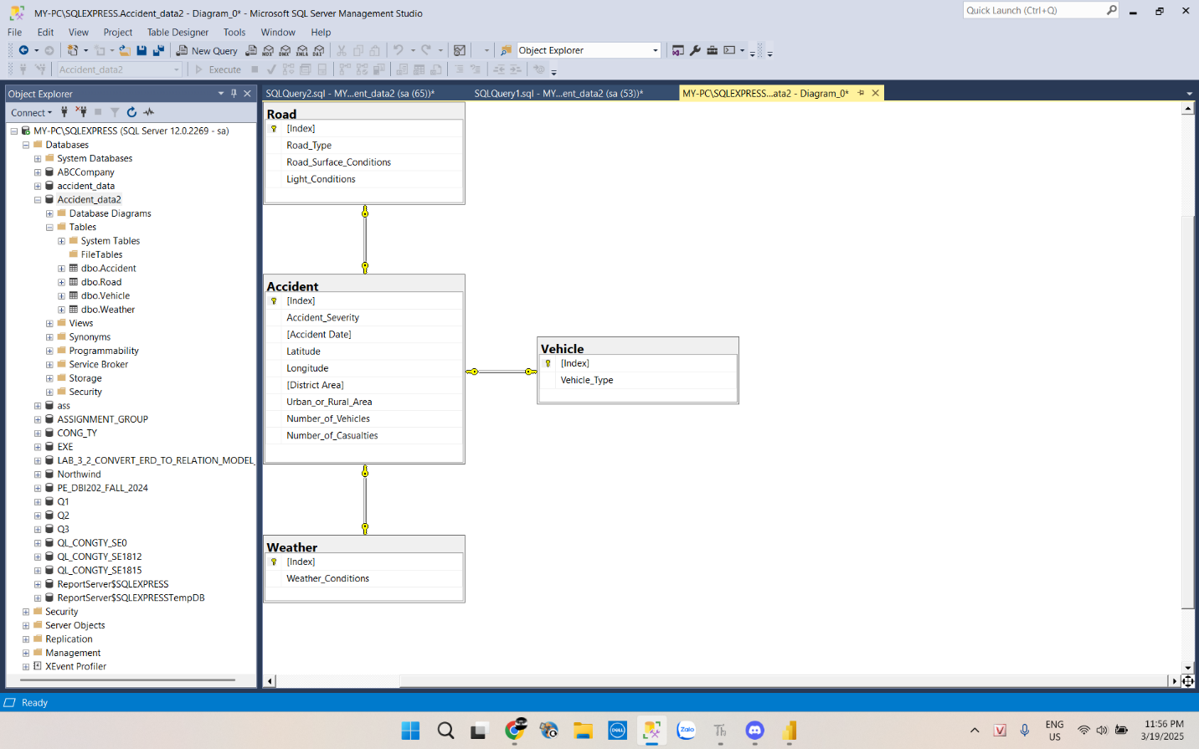

1. Storing data

Tool: Python (Visual Studio Code)

import pandas as pd

import pyodbc

from sqlalchemy import create_engine, text

# 1. Connect to the Accident_data2 database

server = r'DESKTOP-2VLEF98\SQLEXPRESS'

driver = 'ODBC Driver 17 for SQL Server'

db_name = 'Accident_data2'

connection_string = f"mssql+pyodbc://@{server}/{db_name}?driver=ODBC+Driver+17+for+SQL+Server&trusted_connection=yes"

engine = create_engine(connection_string)

# 2. Load data from CSV

df = pd.read_csv('data_accident.csv')

# 3. Get unique values for dimension tables

weather_conditions = df['Weather_Conditions'].drop_duplicates().reset_index(drop=True)

road_types = df[['Road_Type', 'Road_Surface_Conditions', 'Light_Conditions']].drop_duplicates().reset_index(drop=True)

vehicle_types = df['Vehicle_Type'].drop_duplicates().reset_index(drop=True)

# 4. Insert new data into Weather table

with engine.begin() as conn:

for weather in weather_conditions:

conn.execute(text("""

IF NOT EXISTS (SELECT 1 FROM Weather WHERE Weather_Conditions = :weather)

INSERT INTO Weather (Weather_Conditions) VALUES (:weather)

"""), {"weather": weather})

# 5. Insert new data into Road table

with engine.begin() as conn:

for _, row in road_types.iterrows():

conn.execute(text("""

IF NOT EXISTS (

SELECT 1 FROM Road WHERE Road_Type = :road_type

AND Road_Surface_Conditions = :road_surface

AND Light_Conditions = :light_conditions)

INSERT INTO Road (Road_Type, Road_Surface_Conditions, Light_Conditions)

VALUES (:road_type, :road_surface, :light_conditions)

"""), {

"road_type": row['Road_Type'],

"road_surface": row['Road_Surface_Conditions'],

"light_conditions": row['Light_Conditions']

})

# 6. Insert new data into Vehicle table

with engine.begin() as conn:

for vehicle in vehicle_types:

conn.execute(text("""

IF NOT EXISTS (SELECT 1 FROM Vehicle WHERE Vehicle_Type = :vehicle)

INSERT INTO Vehicle (Vehicle_Type) VALUES (:vehicle)

"""), {"vehicle": vehicle})

print("Weather, Road, and Vehicle tables updated successfully!")

# 7. Reload dimension tables

weather_dim_db = pd.read_sql("SELECT * FROM Weather", engine)

road_dim_db = pd.read_sql("SELECT * FROM Road", engine)

vehicle_dim_db = pd.read_sql("SELECT * FROM Vehicle", engine)

# 8. Merge dimension tables into the main dataframe

df = df.merge(weather_dim_db, on='Weather_Conditions', how='left')

df = df.merge(road_dim_db, on=['Road_Type', 'Road_Surface_Conditions', 'Light_Conditions'], how='left')

df = df.merge(vehicle_dim_db, on='Vehicle_Type', how='left')

df.drop(columns=['Weather_Conditions', 'Road_Type', 'Road_Surface_Conditions', 'Light_Conditions', 'Vehicle_Type'], inplace=True)

# 9. Insert data into the Accident table

df.to_sql('Accident', con=engine, if_exists='append', index=False)

print("Accident data inserted successfully!")

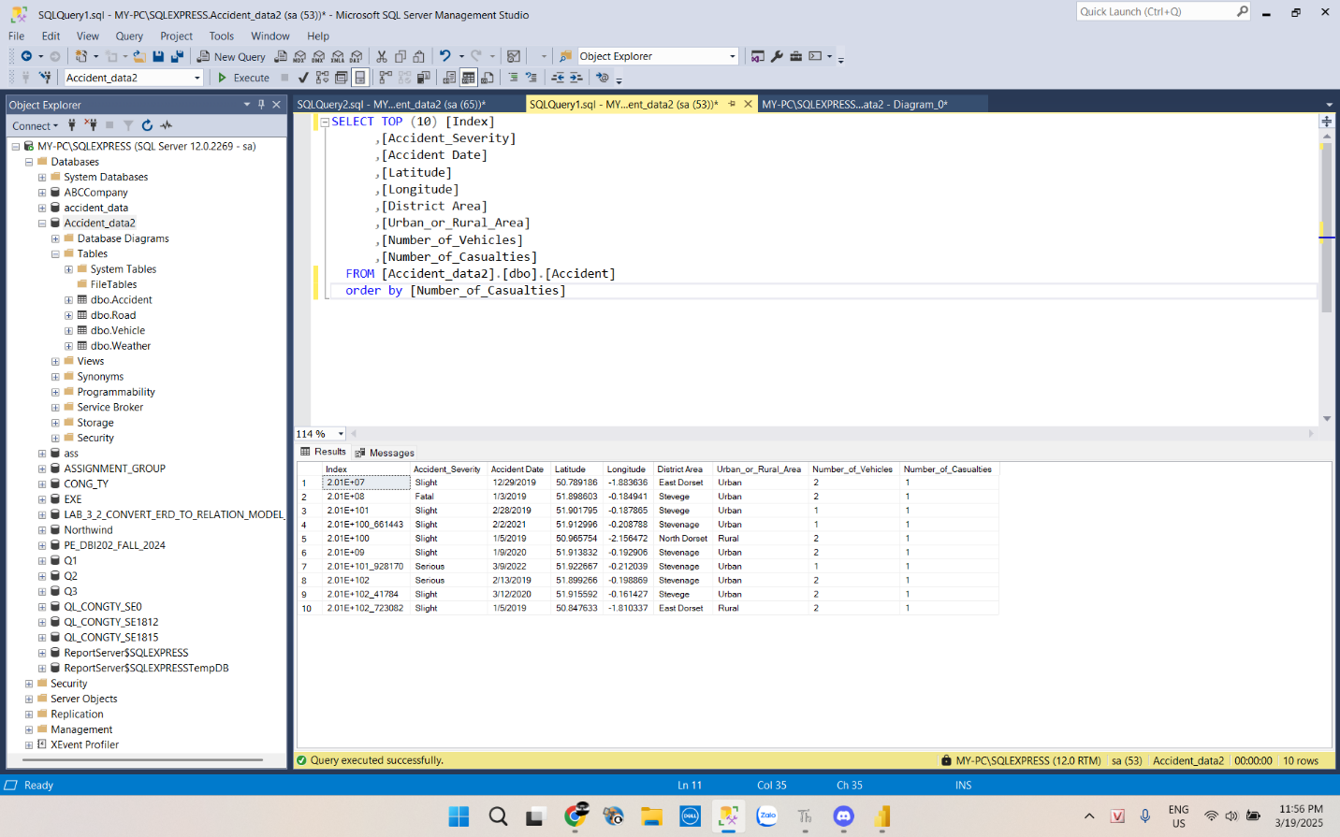

# **6. EDA**

* 1. **Analysis of Quantitative Variables**
  2. **Accident Date**
* **Objective: Analyze accident trends over time.**
* **Code:**

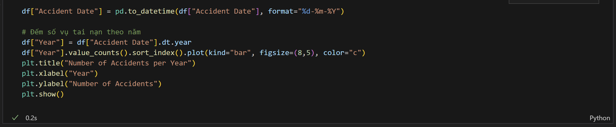

* **Ouput:**

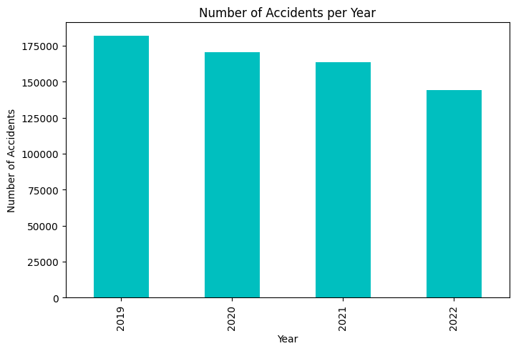

* **Whether accidents are decreasing over the years.**
  1. **Latitude & Longitude (Accident Location)**

**- Objective: Identify accident hotspots on a map**

* 1. **Number_of_Casualties**

**- Objective: Analyze the average number of casualties per accident.**

* 1. **Number_of_Vehicles**

**-Objective: Determine if accidents involve multiple vehicles.**

**Code:**

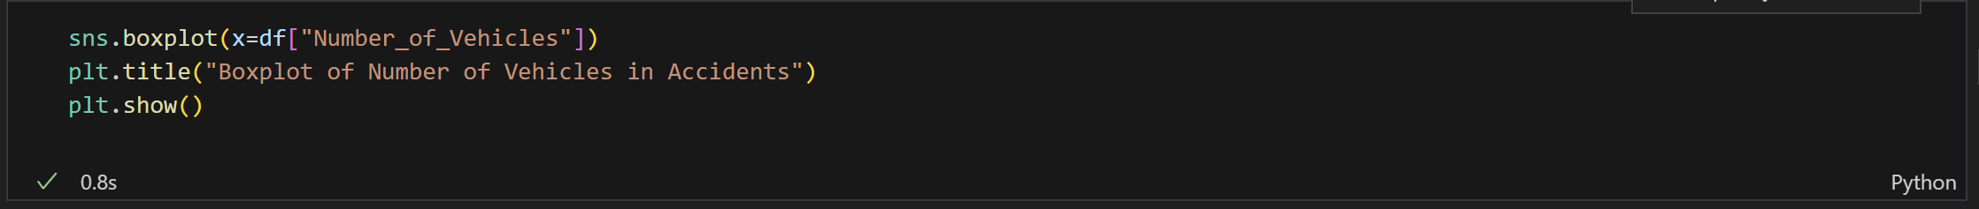

* **Output:**

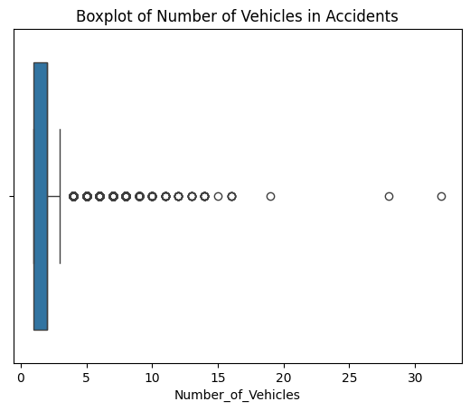

* **Most accidents involve only a few vehicles, but there are extreme cases with many vehicles involved. These could be due to factors like high-speed highways, foggy conditions, or chain-reaction crashes.**
  1. **Analysis of Qualitative Variables**
  2. **Light_Conditions (Lighting Conditions)**

**- Objective: Identify whether most accidents occur during the day or at night.**

**- Code:**

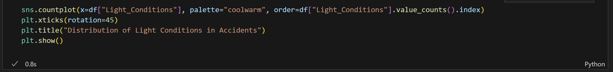

* **Output:**

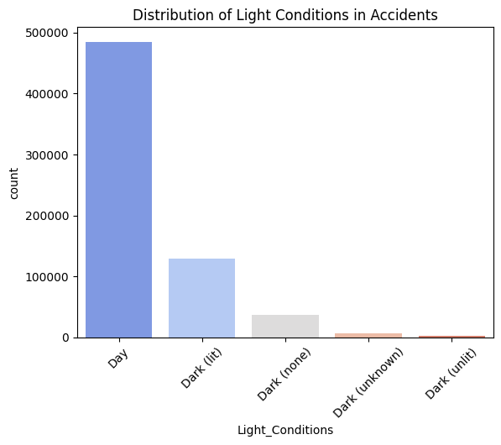

* **Accidents are usually occurring in day** 
  1. **District Area**

**- Objective: Identify which districts have the highest accident rates.**

**- Code:**

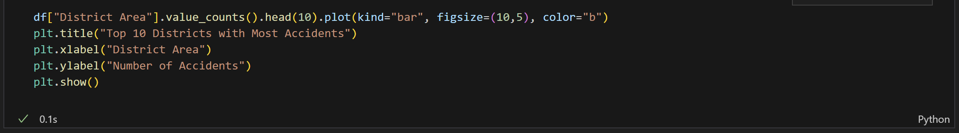

* **Output:**

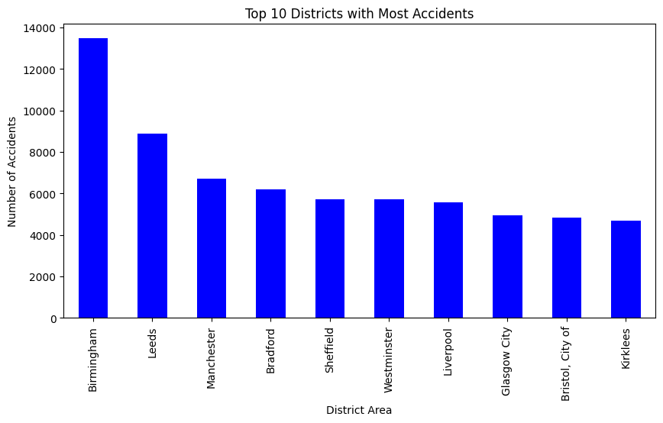

* 1. **Road_Surface_Conditions**

**- Objective: Analyze how road conditions affect accidents.**

**-Code:**

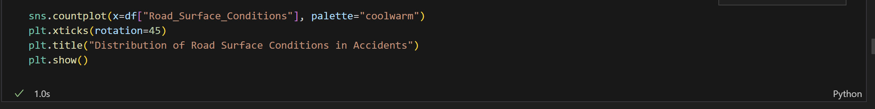

* **Output:**

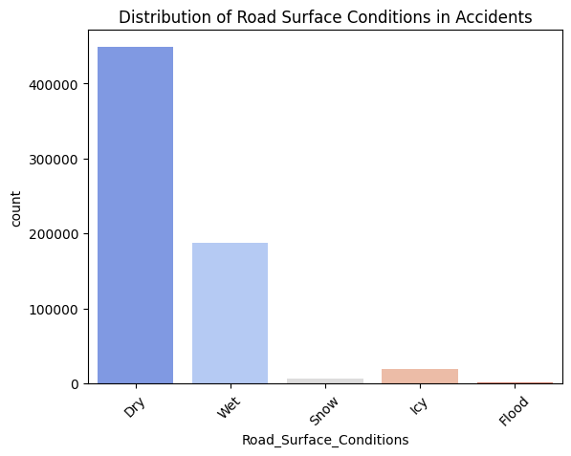

* 1. **Road_Type**

**- Objective: Identify which road types have the highest accident rates.**

**-Code:**

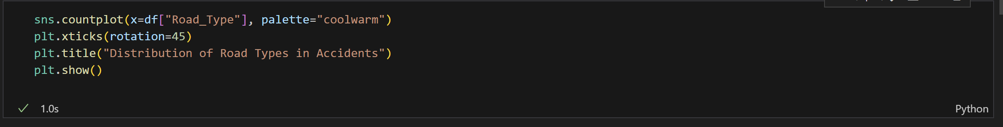

* **Output:**

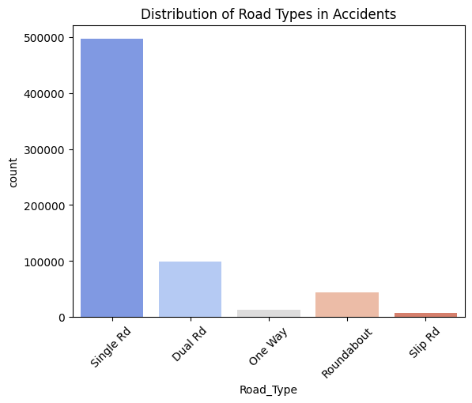

* 1. **Urban_or_Rural_Area (Urban vs. Rural)**

**- Objective: Compare accident rates between urban and rural areas.**

**-Code:**

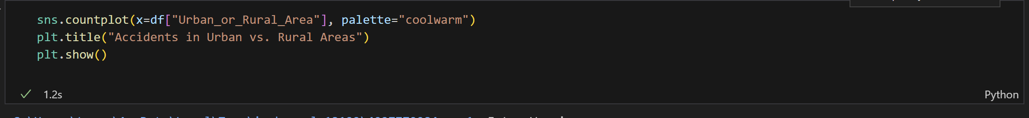

* **Output:**

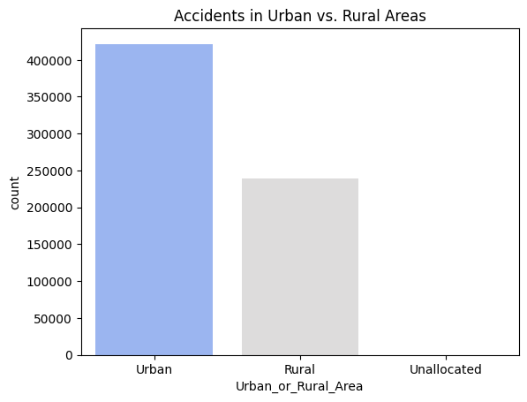

* 1. **Vehicle_Type**

**- Objective: Identify which vehicle types are most commonly involved in accidents.**

**-Code:**

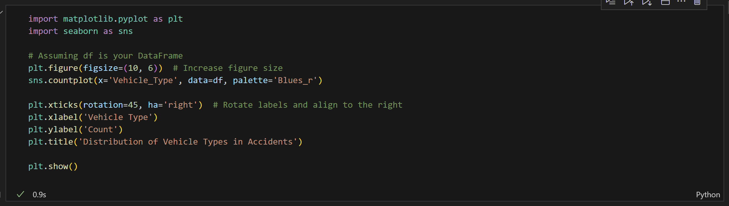

* **Output:**

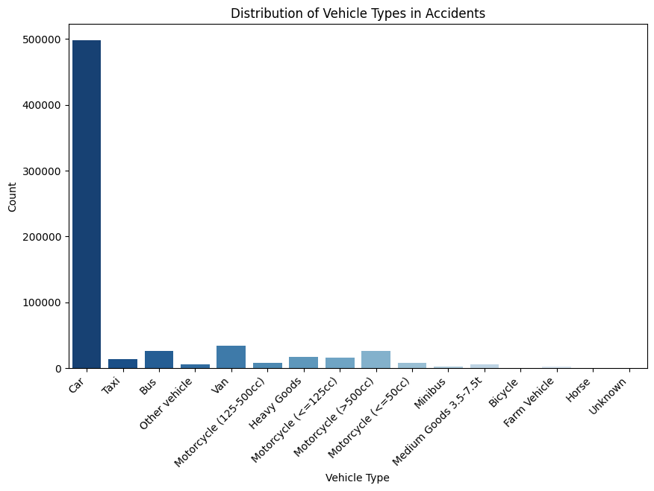

## **6.3 Visualization**

## **- Correlation**

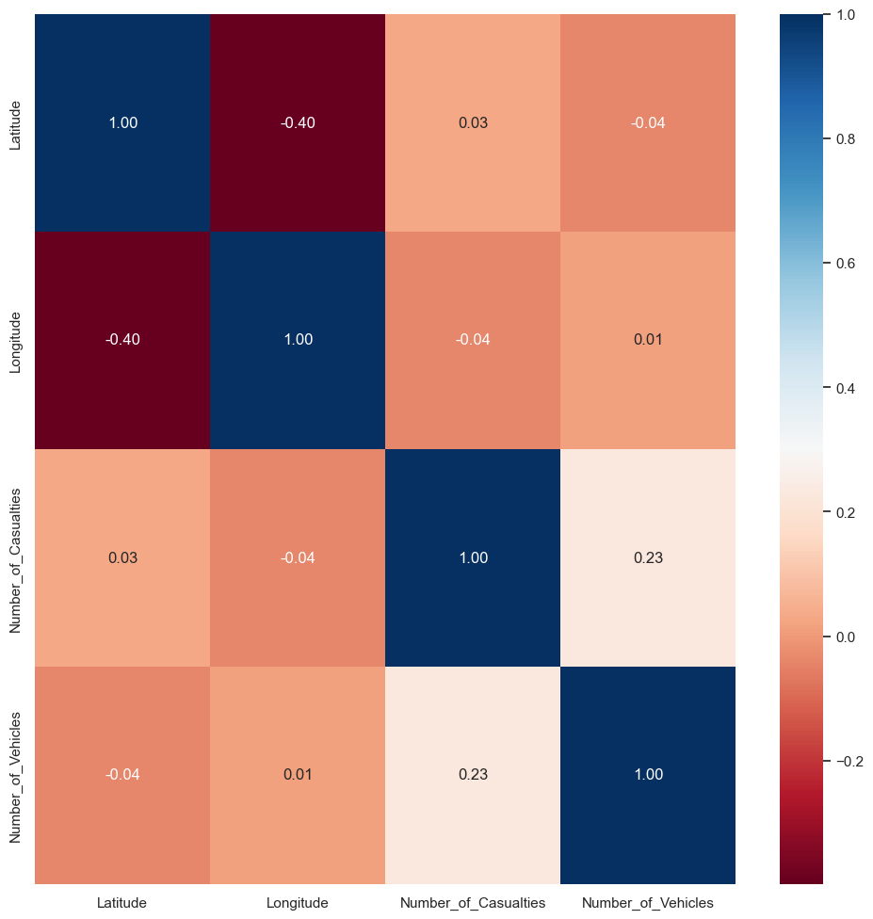

## **- Matrix covariance**

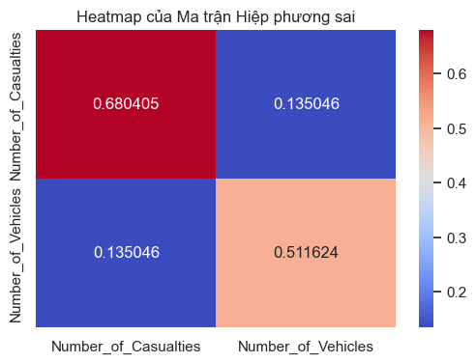

## **Scatter_matrix**

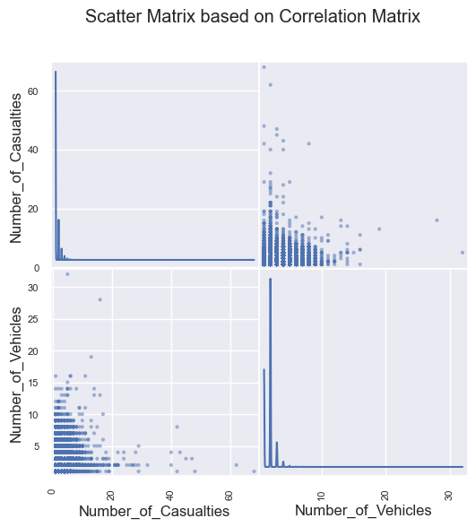

# **7.Inferential Analysis**

* 1. **ANOVA test (one-way) to check the influence of Number_of_Casualties on Accident_Severity**

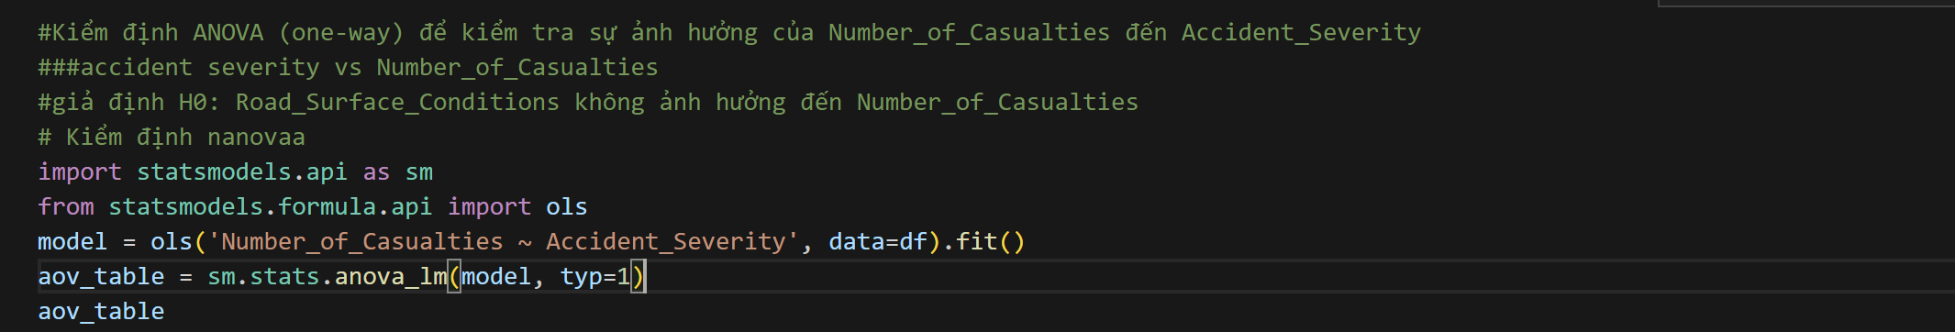

* **Ouput:**

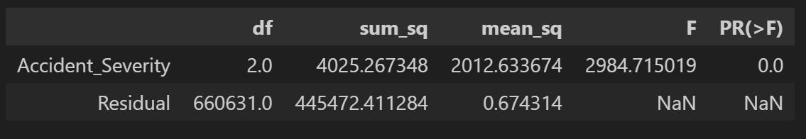

* **Number_of_Casualties has a dependency on Accident_Severity**
  1. **ANOVA test (one-way) to check the influence of Number_of_Casualties Accident_Severity**
* **Code:**

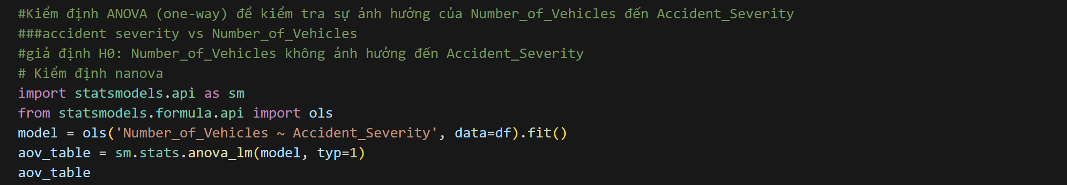

* **Output:**

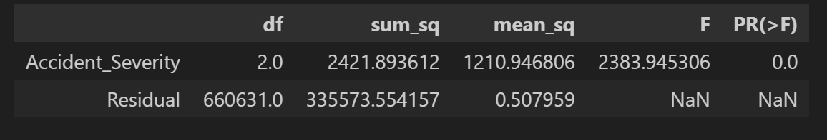

* **Number_of_Casualties ,Number_of_Vehicles has a dependency on Accident_Severity**
  1. **Chi-Square test to examine the influence on Accident_Severity**
     1. **Road_Surface_Conditions**

**Code:**

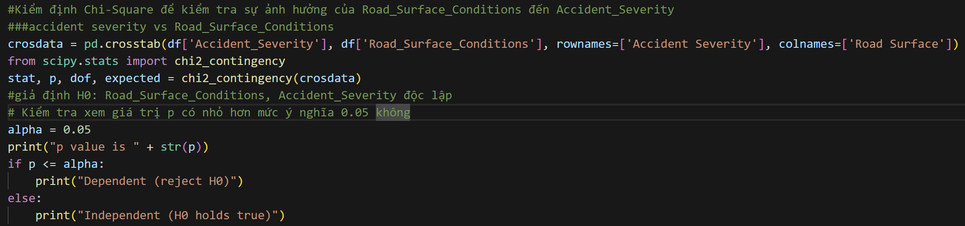

* **Output:**

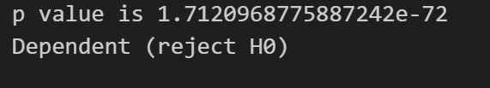

* **There is a dependency between Road_Surface_Conditions and Accident_Severity**
  + 1. **Light_Conditions**

**Code:**

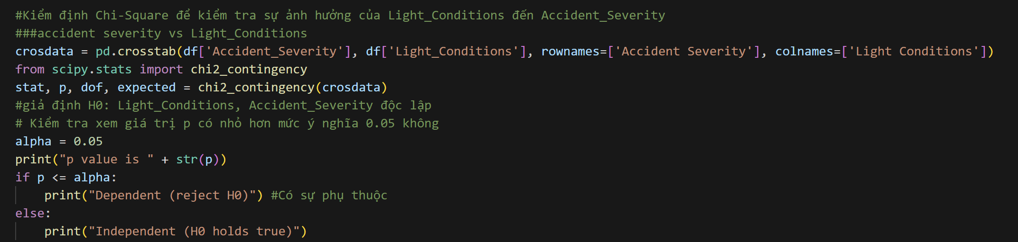

* **Output:**

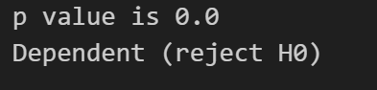

* **There is a dependency between Conditions and Accident_Severity**
  + 1. **Road_Type**

**Code:**

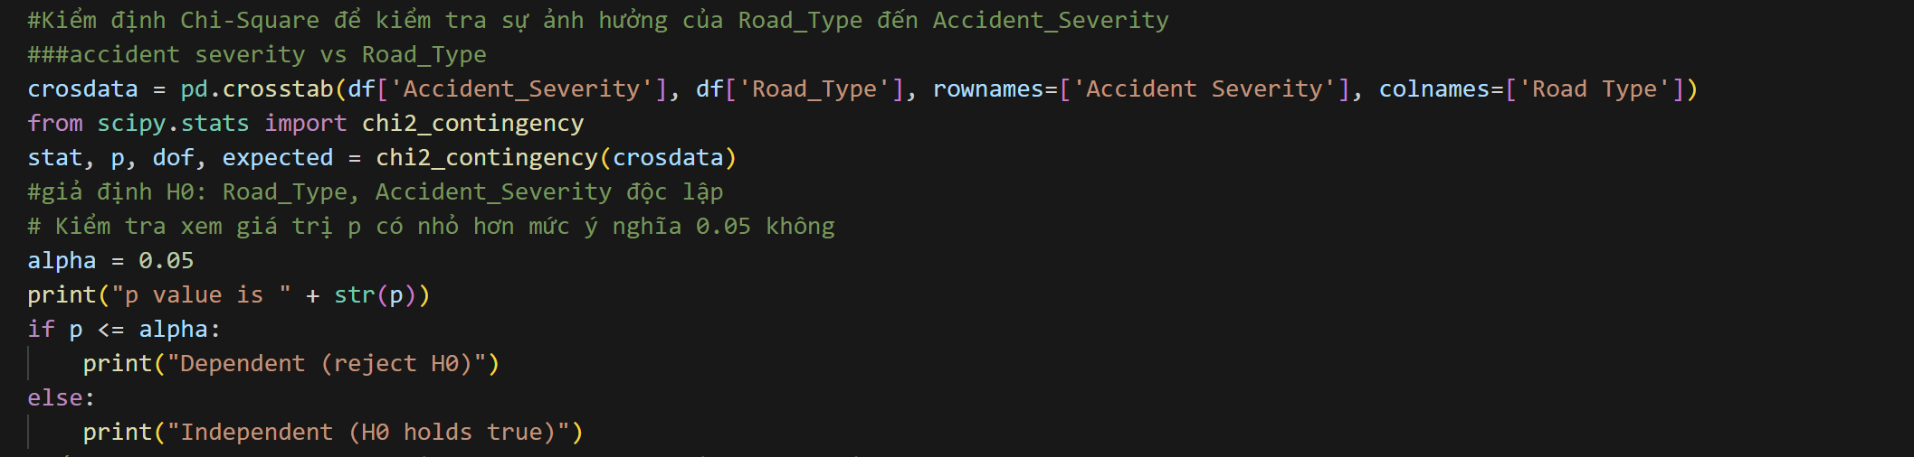

* **Output:**

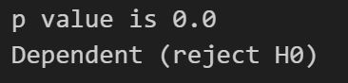

* **There is a dependency between Conditions and Accident_Severity**
  + 1. **Vehicle_Type**

**Code:**

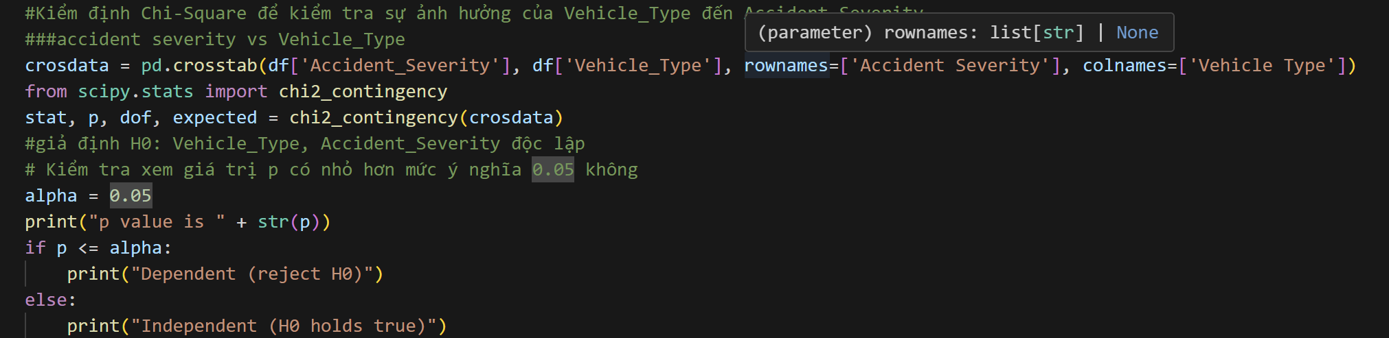

* **Output:**

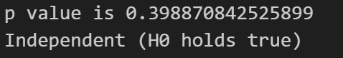

* **There is not a dependency between Conditions and Accident_Severity**
  + 1. **Urban or Rual Area**

**Code:**

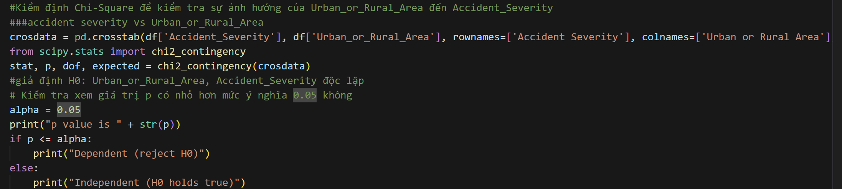

* **Output:**

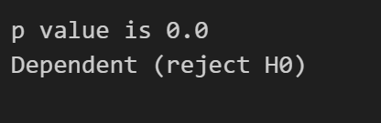

* **There is a dependency between Conditions and Accident_Severity**
  + 1. **Weather_Condition**

**Code :**

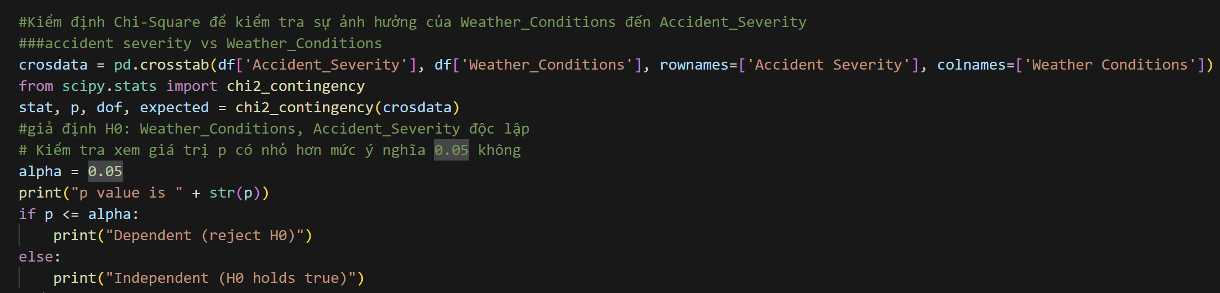

* **Output:**

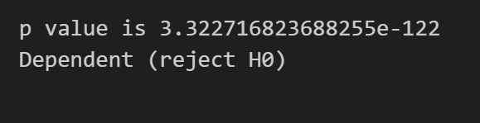

* **There is a dependency between Conditions and Accident_Severity**
  + 1. **District_Area**

**Code:**

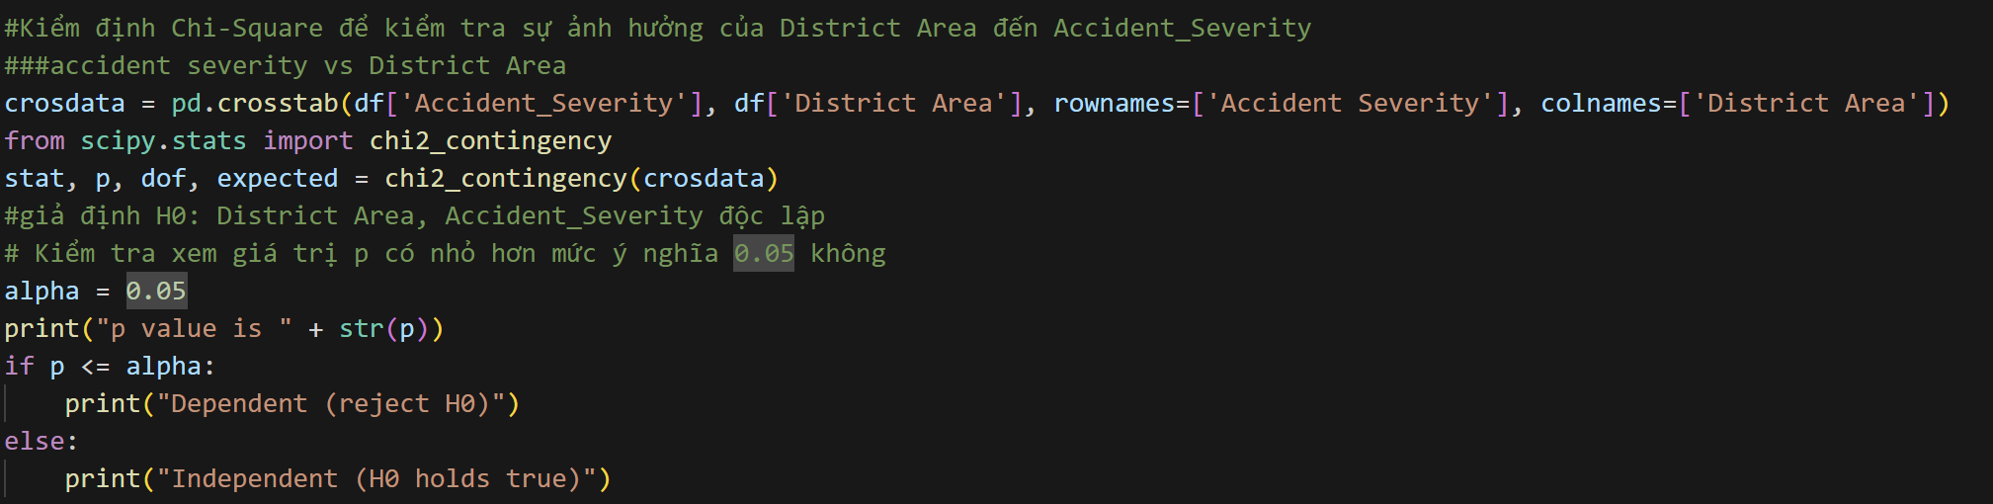

* **Output:**

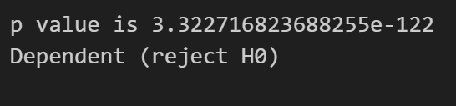

* **There is a dependency between Conditions and Accident_Severity**
* **Conclusion: Road_Surface_Conditions, Light_Conditions, Road_Type, Urban_or_Rural_Area, District Area, Urban_or_Rural_Area, Weather_Conditions have an influence on Accident_Severity**

# **8.Feature Selection**

* 1. **Impact of Features on the Target Variable**
  2. **Introduction to the Methodology**

**-** **To determine the impact of features on the target variable, we use a Logistic Regression model with data standardized using StandardScaler. The coefficients of each feature indicate their level of influence on the dependent variable.**

* 1. **Interpreting the Coefficients**

**- Explain the meaning of feature coefficients**

* **A positive coefficient means the feature has a positive impact on the target variable.**
* **A negative coefficient indicates a negative impact on the target variable.**
* **The larger the absolute value of a coefficient, the stronger its influence.**
  1. **Code**

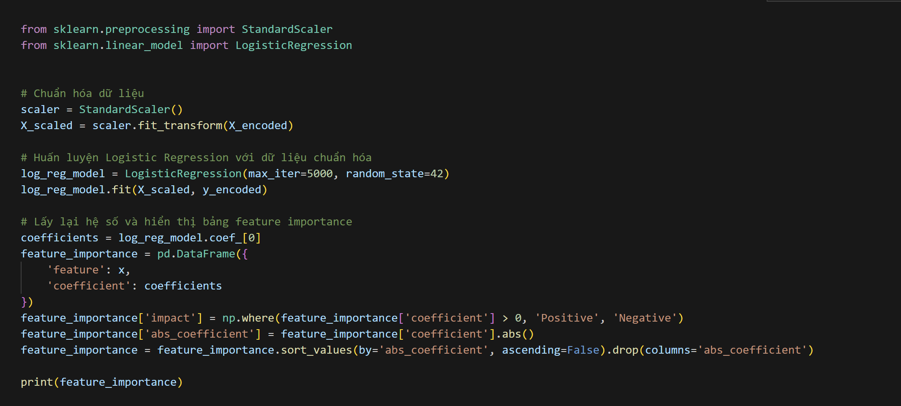

* + **Result:**

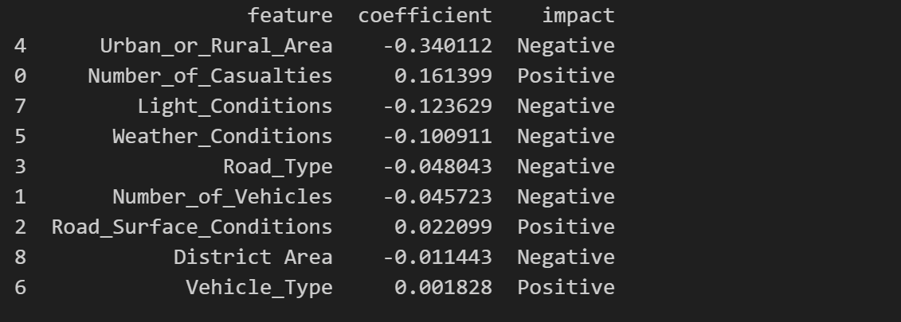

* **Based on the results, the top 5 most influential features are:**

1. **Urban_or_Rural_Area (-0.340112) → Negative impact**
2. **Number_of_Casualties (+0.161399) → Positive impact**
3. **Light_Conditions (-0.123629) → Negative impact**
4. **Weather_Conditions (-0.100911) → Negative impact**
5. **Road_Type (-0.048043) → Negative impact**
   1. **Find Insight**
6. **Urban_or_Rural_Area**

* **Severity by area:**
* **Code:**

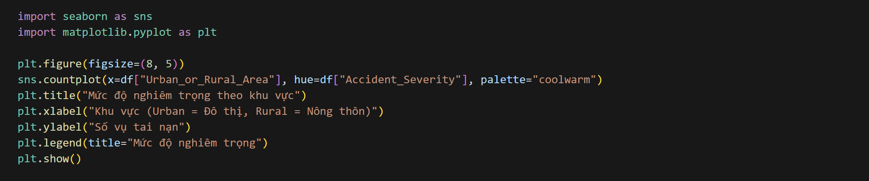

* **Result:**

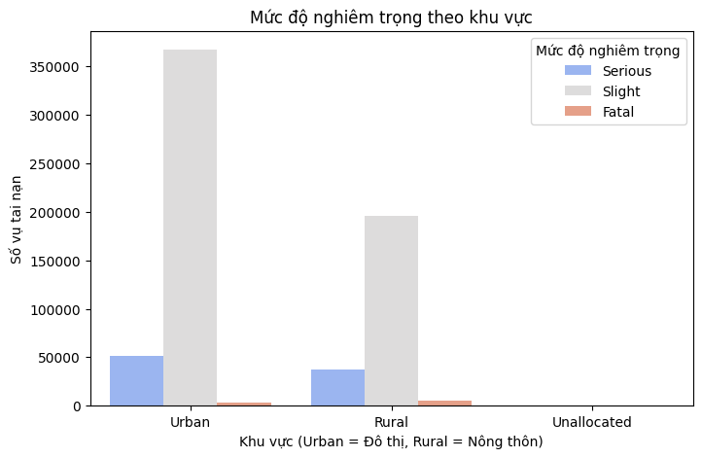

* **Serious accident rate between the two area**
* **Code:**

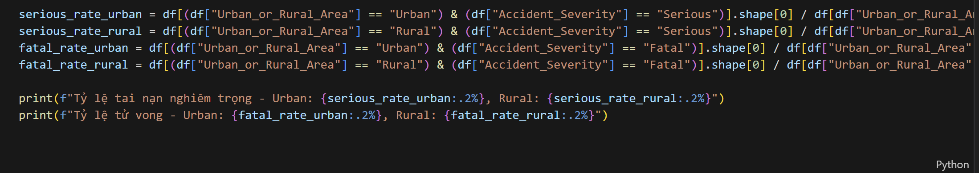

* **Result:**

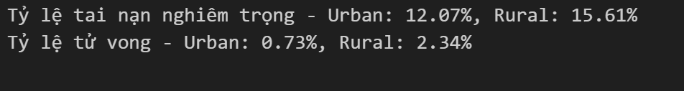

* **Conclusion:**
* **The rate of serious accidents is higher in rural areas (Rural: 15.61% > Urban: 12.07%)**
* **Although the total number of accidents in urban areas is higher, the rate of serious accidents in rural areas is higher.**
* **The reasons may be due to:**
  + **Higher speed: In rural areas, vehicles move at higher speeds due to wide roads and fewer traffic lights.**
  + **Lack of nearby medical facilities: Emergency treatment takes longer, increasing the risk of serious injuries.**
  + **Poorer road quality: Roads have potholes, lack of signs, no median strip.**
* **The mortality rate in rural areas is significantly higher (Rural: 2.34% > Urban: 0.73%)**
* **Accidents in rural areas are nearly 3.2 times more likely to result in death than in urban areas.**
* **The reasons may be due to:**
  + **High-speed collisions → More serious accidents.**
  + **Lack of street lights & night lighting → Drivers have difficulty reacting in time.**
  + **Inadequate emergency response system → The golden time to save the victim's life is extended.**

1. **Number_of_Casualties**

* **Compare casualties by severity**
* **Code:**

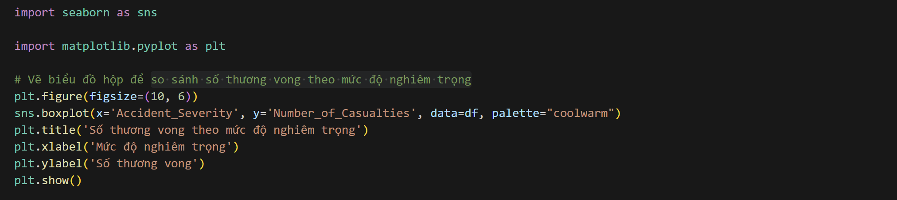

* **Result:**

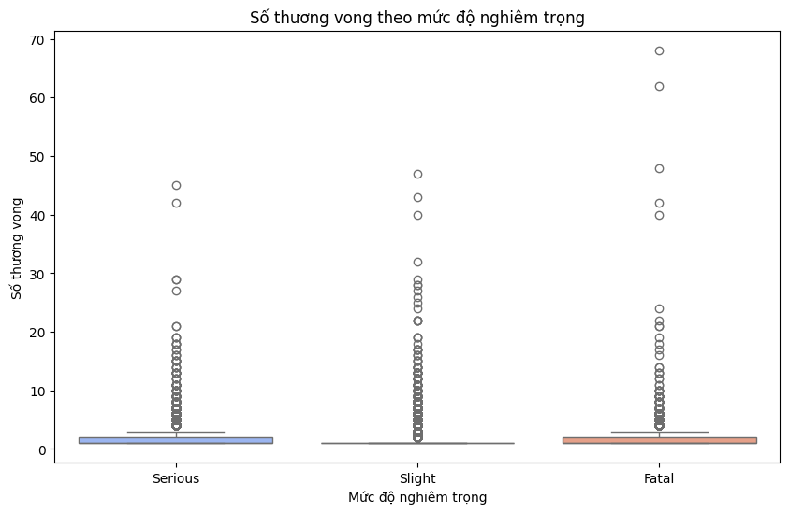

* **Most accidents have low casualty numbers, with a fairly small median value.**
* **There were more accidents with higher casualties, but the main distribution remained low.** **There were several accidents resulting in more than 50 casualties, suggesting it could be a bus accident or a major traffic accident.**
* **Relationship between Number_of_Vehicles and Number_of_Casualties**
* **Code:**

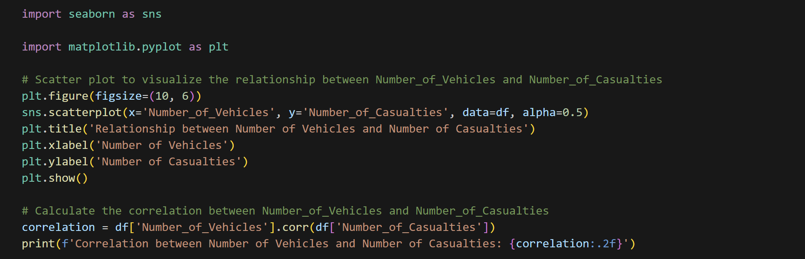

* **Result:**

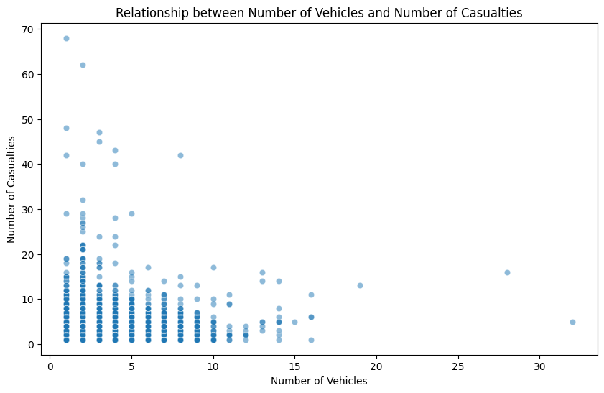

**-** **Correlation between Number of Vehicles and Number of Casualties: 0.23**

* **Very weak correlation (Correlation = 0.23)**
* **The correlation value of 0.23 shows that the relationship between the number of vehicles and the number of casualties is very weak, with almost no clear trend.**
* **This means that accidents with more vehicles do not necessarily have more casualties.**

1. **Light Condition**

* **Compare accident severity over time**
* **Code:**

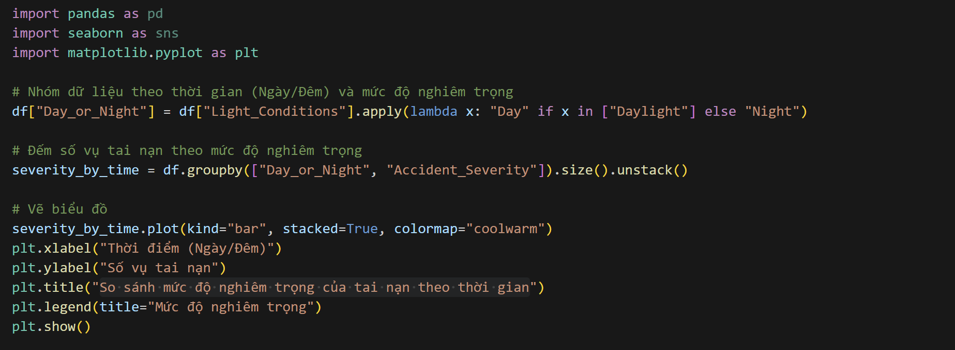

* **Result:**

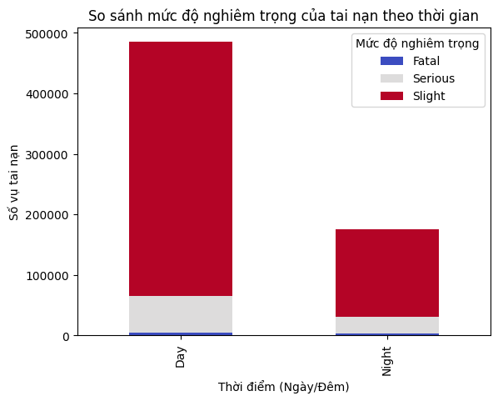

* **The total number of accidents is higher during the day than at night, but the rate of serious accidents is higher at night (15.62% vs. 12.53%).**
* **Fatalities may be higher at night, due to poor lighting conditions, drivers tend to be more tired or more likely to speed.**
* **The difference in severity may be related to traffic conditions, for example:**
* **More vehicles during the day → more accidents but usually at low speeds → less serious.**
* **Less roads at night → higher speeds → when accidents do occur, they are more serious.**
* **Number of Serious Accidents at Night by Road Type**
* **Code:**

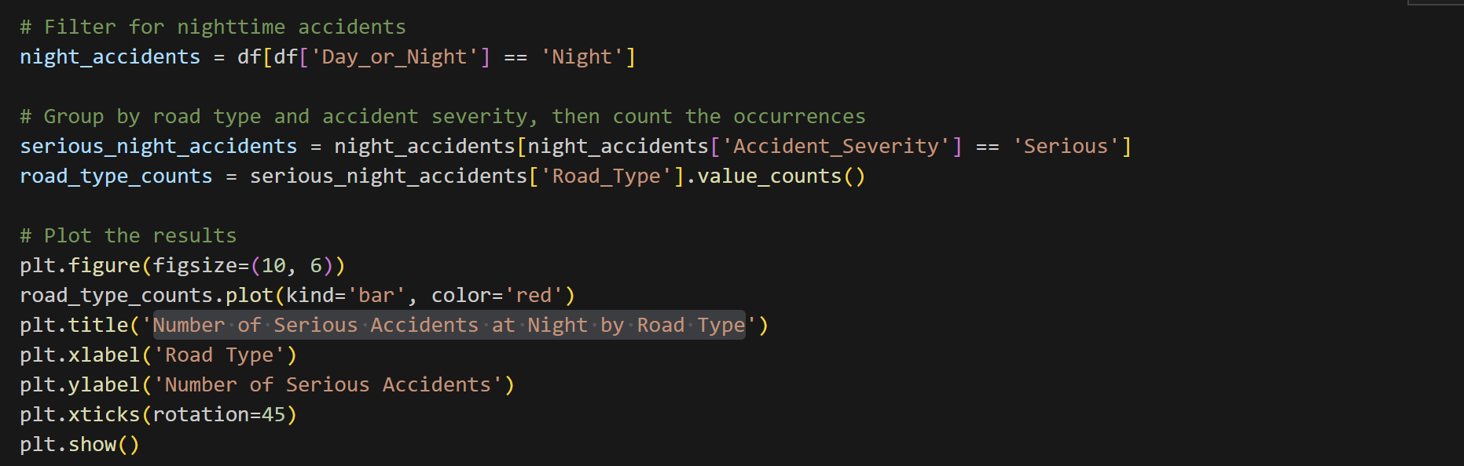

* **Result**

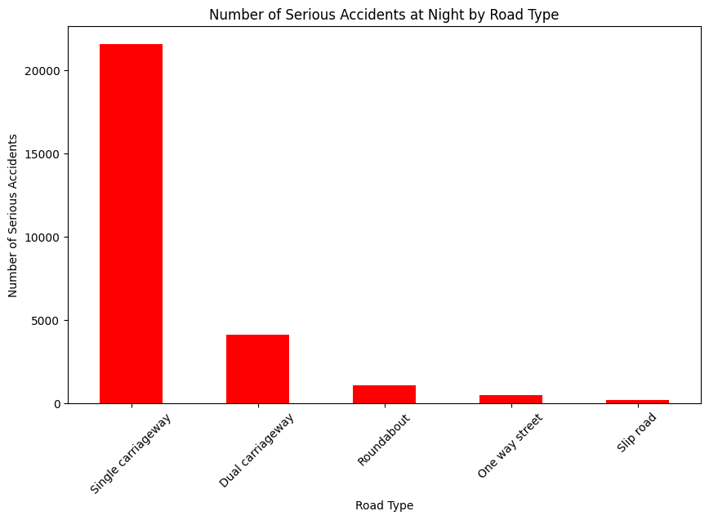

**- The number of serious accidents on Single Carriageways far exceeds other road types, possibly due to high speeds, poor visibility, and few street lights at night.**

**- Dual Carriageways have the second highest number of accidents, but are significantly lower than Single Carriageways.**

**- Areas such as Roundabouts, One way streets, and Slip roads have very low numbers of serious accidents at night, possibly due to lower traffic volumes or better safety measures.**

**-> Single Carriageways need safety improvements, such as increased lighting or speed limits at night.**

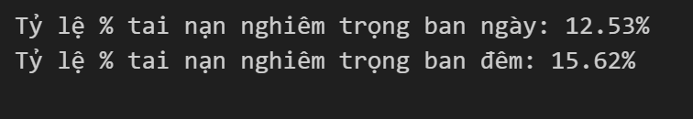

* **There may be fewer vehicles at night, but accidents that do occur tend to be more serious.**
* **Potential causes: poor visibility, higher speeds, deserted roads that can cause loss of control, drowsy or drunk drivers.**

1. **Weather Condition**

* **Accident severity across different weather conditions**
* **Code:**

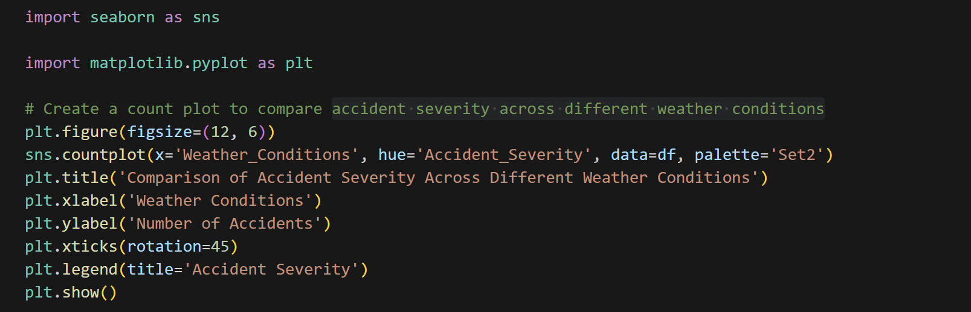

* **Results:**

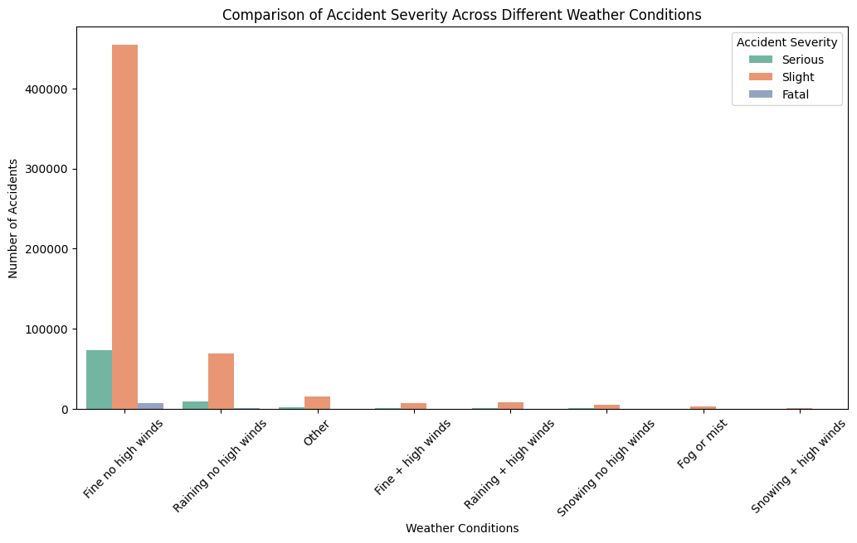

* **Clear no high winds has the most accidents because it is common.**
* **Raining no high winds is also dangerous but less so.**
* **Worse weather has fewer accidents, probably due to less traffic**
* **Severity in bad weather conditions, rural areas at night**
* **Code:**

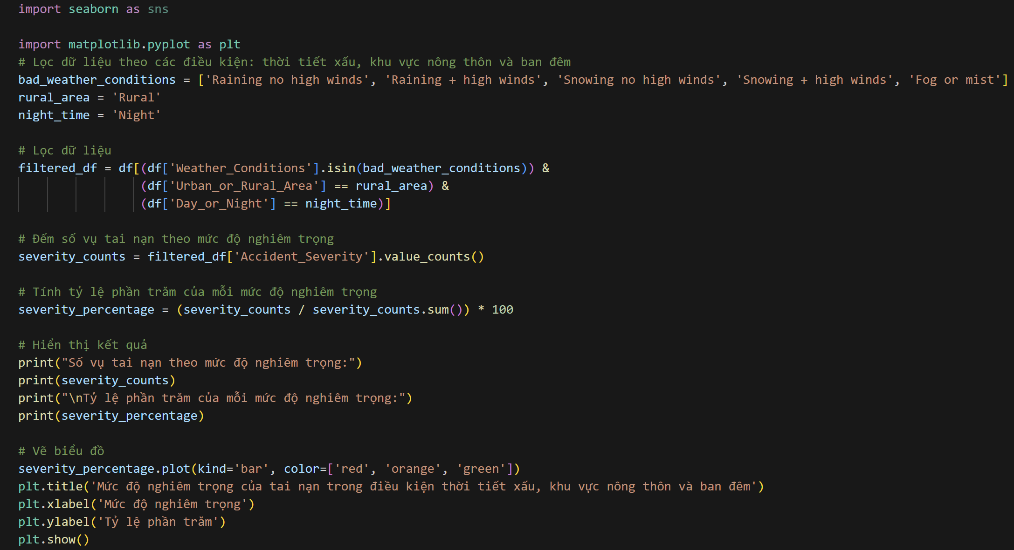

* **Results:**

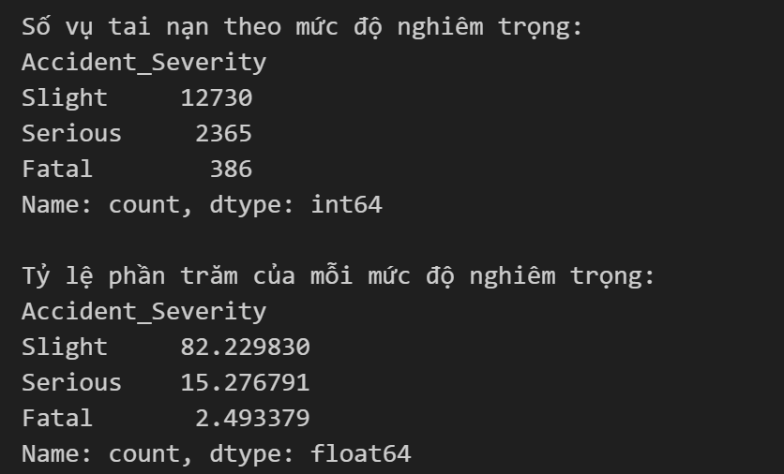

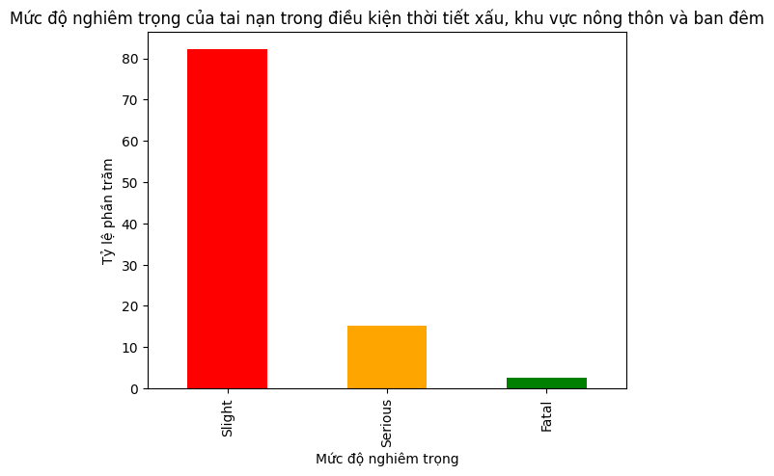

* **Slight accidents account for the majority (over 80%)**
* **Although bad weather, rural areas and nighttime can increase the risk of accidents, the majority of accidents are still minor.**
* **This may be because most road users still follow safety measures or the speed is not too high.**
* **Serious accidents account for about 15%**
* **The number of serious accidents is not small, showing that there are still many cases of serious injuries in these adverse conditions.**
* **Factors that may contribute to the increased severity:**
* **Poor visibility due to weather and lack of street lighting.**
* **Speeding or loss of control of the vehicle on slippery roads.**
* **Delays in emergency care in rural areas.**
* **Deadly fatal accidents are low (2.49%) but still worrying**
* **Although the rate is small, 386 fatalities is a remarkable number.**

1. **Road Type**

* **Check the distribution of Road Type**
* **Code:**

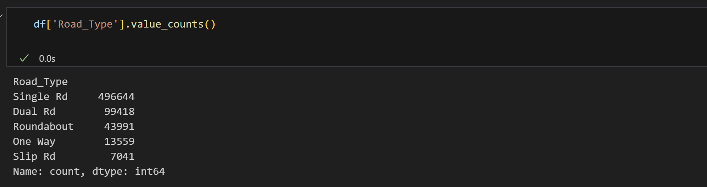

* **Most accidents happen on single carriageways (two-way roads without medians).**
* **Dual carriageways (roads with medians) have fewer accidents, possibly due to higher speed limits, but are also safer.**
* **How does Road Type affect casualties?**
* **Code:**

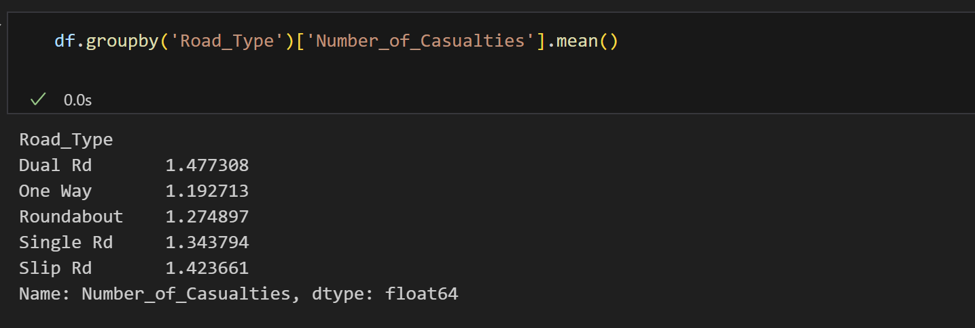

* **Serious + Fatal accident rates for each road type**
* **Code:**

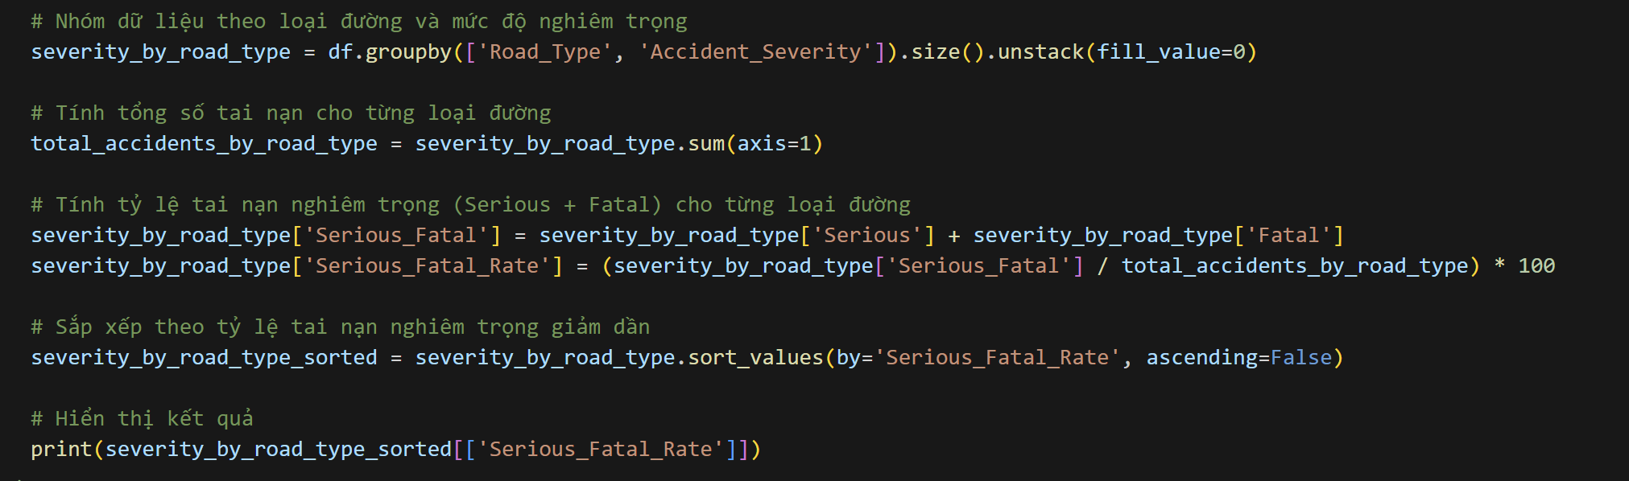

* **Result:**

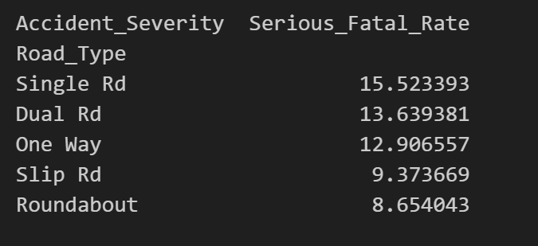

* **Columns chart:**

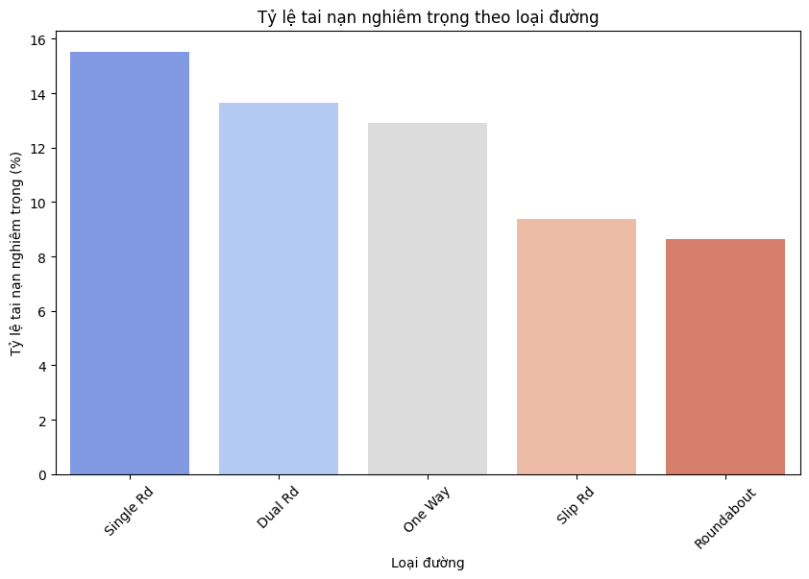

* **Single carriageways are the most dangerous road types, but the average number of fatalities is not too high.**
* **Dual carriageways are more dangerous, with a higher average number of fatalities.**
* **Roundabouts and one-way streets are relatively safer than other road types.**
* **Accidents on motorways or slip roads are less common, but can be serious due to high speeds.**
* **Appropriate safety measures are needed for each type of road, such as speed control on dual carriageways, increased warnings on single carriageways, and improved roundabout design to increase safety.**

**9.Business Intelligence**

* 1. **Dashboard Power Bi**

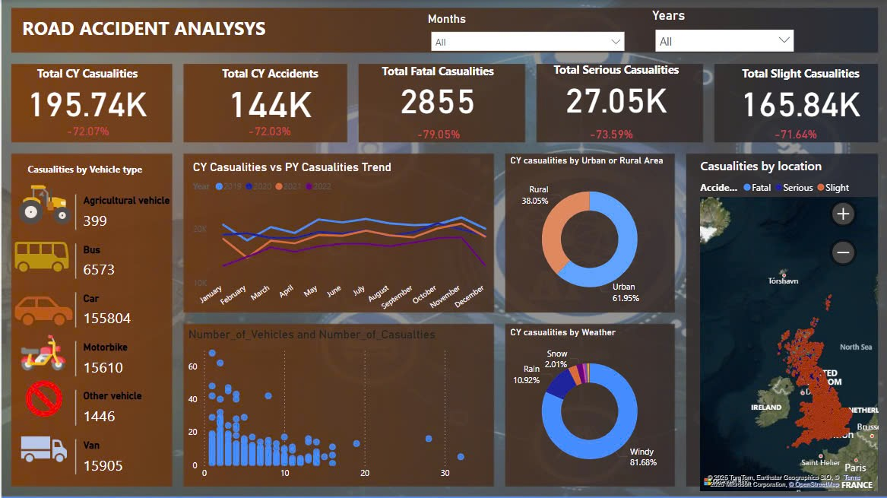

* **Bar chart comparing accident severity by weather conditions, lighting and road type.**

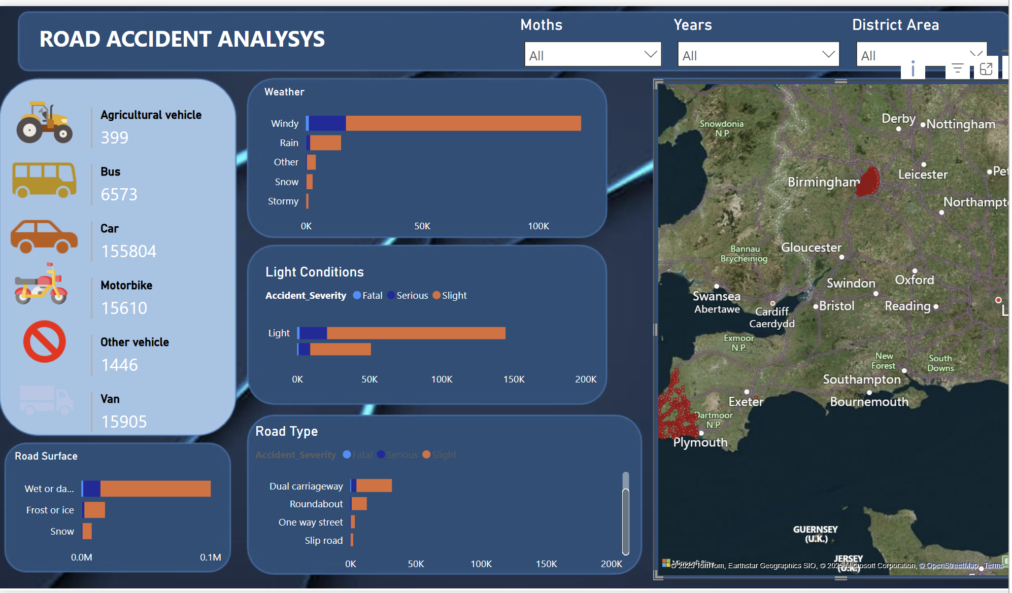

* + 1. **Conclusion**

The study analyzed the key factors affecting the severity of road accidents using data from the UK (2019-2022). The results highlight several significant findings:

* **Lighting Conditions:** Accidents that occur at night without street lighting tend to be more severe.
* **Road Type:** Single-lane roads and rural areas have a higher percentage of serious accidents due to high-speed driving.
* **Weather Conditions:** Rainy conditions contribute to a significant number of accidents, while extreme weather conditions such as fog and snow have a lower impact due to reduced traffic.
* **Vehicle Type:** Motorcycles and bicycles experience higher casualty rates compared to cars and heavy vehicles.

These insights can help policymakers and traffic safety agencies implement measures such as **improving road lighting, enhancing speed limits, and optimizing emergency response strategies** to reduce accident severity.